Equality and Human Rights Commission

Civil Legal Advice: analysis of specialist provider data

June 2019

Rebecca Kaye

(Numbertelling)

Contents

1. Background 3

2. Total callers 6

3. Overview of matters taken on 8

4. Time spent and stage reached analysis 13

5. Positive outcome analysis 19

6. Disability analysis 25

7. Language difficulties analysis 30

8. Face-to-face analysis 31

9. Referral source analysis 33

10. Exempted cases analysis 36

11. Failed to supply evidence analysis 37

12. Determinations 40

13. Conclusions 48

Appendix A: Grouping criteria 51

Appendix B: Data quality 59

1. Background

The Equality and Human Rights Commission (‘the Commission’) commissioned Numbertelling in November 2018 to assist with its inquiry into legal aid for the victims of discrimination. This report assesses the provision of legal aid for discrimination claims via the mandatory Civil Legal Advice (CLA) telephone gateway.

Numbertelling’s work involved analysing a dataset provided by the Legal Aid Agency (LAA) that contains details of all discrimination cases reported as closed by CLA specialist providers of discrimination advice during the relevant period. The dataset includes information such as age, gender, ethnicity, disability, ‘matter type’ (the broad area of the discrimination claim, such as employment or the provision of goods and services), protected characteristic (that is, which Equality Act 2010 protected characteristic the case concerns) and the outcome information of the case (to what stage the case was assisted and whether the outcome was positive). The dataset also includes records that were referred through CLA to a specialist provider but not taken on as a case. The dataset covers England and Wales (but not Scotland) and contains all relevant records from 2013/14 to 2017/18. It should be noted that some cases may have been dealt with, but not yet reported as closed by the specialist provider; these would not appear in the dataset.

Calls to the CLA are answered by an operator service that identifies whether the client’s problem is in scope of legal aid and whether it is in a category of law, such as the Discrimination category, which is covered by the CLA. If so, the operator will carry out a financial eligibility assessment. If the client is eligible under this assessment, the operator service will transfer them to a specialist provider. The first step the specialist provider must take is to assess whether the client is eligible to have their case taken on. This requires reassessing the operator’s assessment of financial eligibility, and determining whether the problem is within the scope of legal aid discrimination work. The specialist provider must also assess the merits of the case.

A problem that fails to meet these tests for assistance by the specialist provider is known as a ‘determination’ and is not taken on as a case. Determinations have been identified using the criteria laid out in Appendix A (Table A1.2). These constitute a total of 9,946 cases, equivalent to 56.1% of the total number of records in the dataset. The remaining 43.9% of records (7,768 contacts) were taken on as ‘matters’ by the specialist provider. All but three of the total contacts in the dataset (17,714 records) were either determined or taken on as matters. These remaining three records have been excluded from further analysis as they were exempted cases (discussed in Section 10 of this report).

The dataset overall had very few data errors and made sense from a dataflow point of view; for example, disability-related cases generally involved a disability identified in the disability field. More information on data quality is laid out in Appendix B. One issue is, however, discussed further in this report: the high number of ‘unknown’ or ‘other’ codes provided for some categories.

The data provided to Numbertelling by the LAA showed consistencies with previous analysis on similar referrals. Specifically, the Commission asked Numbertelling to compare the data with an earlier analysis of the CLA data by Ash Patel, then of the Ministry of Justice.[1] Numbertelling cross-referenced available information to ensure that the analysis in this report has consistent figures with those used in Patel’s report. Overall, the data used for both reports was very similar and showed similar findings.

Following data quality assurance and comparative analysis, the complete dataset provided by LAA was then analysed by Numbertelling to determine patterns and trends in all the available information and to determine if certain factors influenced the outcome or stage of cases. These results are detailed in the following pages.

Although this dataset does contain a small number of records that are likely to relate to matters in which a Public Funding Certificate (PFC) was issued by the LAA to carry out further work, these records have not been separately analysed within this report. The LAA provided Numbertelling with a more detailed dataset pertaining to PFC matters and this data has been analysed in a separate report, ‘Civil legal advice: analysis of Public Funding Certificate data’.

Shortly before the completion of this report, the Ministry of Justice published the ‘Post-Implementation Review of Part 1 of the Legal Aid, Sentencing and Punishment of Offenders Act 2012 (LASPO)’ (hereafter, ‘the LASPO Review’).[2] Section 13 of this report (‘Conclusions’) draws some comparisons between the findings of the analysis within this report and the LASPO Review. It should be noted that the terminology used in this report and in the LASPO Review differ; in the latter report, ‘matters’ are referred to as ‘acts of assistance’, while ‘determinations’ are referred to as ‘other work done’.

1. Total callers

Table 2.1 was provided by the LAA and summarises the number of records flowing through the mandatory CLA telephone gateway.

Table 2.1 Civil Legal Advice records, 2013/14 to 2017/18

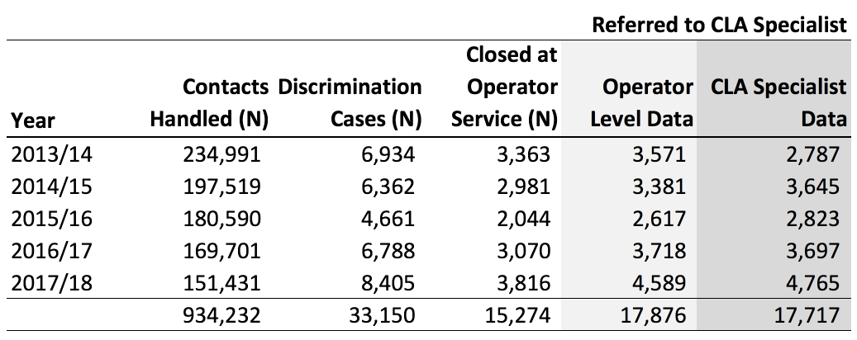

Note: The data in the first four columns of the table was provided by the LAA. The final column was prepared by Numbertelling following analysis of the detailed dataset. The figures in the final column match those shown in Figure 80 of the LASPO Review on ‘acts of assistance and other work done’, once rounding is taken into account.

The total number of calls decreased steadily over the five-year period between 2013/14 and 2017/18. However, the number of calls about Discrimination cases increased after 2015/16 (despite initially falling). Similarly, despite a drop in 2015/16, referrals from the operator service to a CLA specialist provider also increased between 2013/14 and 2017/18. Whether this trend will continue in 2018/19 remains to be seen as the data is not yet available. However, as explained in the following sections, the number of matters reported as closed by the specialist providers has declined since 2014/15.

The final column in Table 2.1 (’CLA Specialist Data’) has been added by Numbertelling and shows the number of cases referred to a specialist provider according to the detailed dataset that was provided by the LAA, on which the rest of the report is based. The data that Numbertelling received does not align fully with the summary data provided by the LAA. These differences could be due to a number of factors. The most likely reason for the differences (as confirmed by the LAA) is that some cases span multiple years, which means that a case could be assigned to financial year X in one dataset and financial year Y in another. The timing difference was larger in 2013/14 than in later years because this was the first year that the Discrimination category was recorded, so there were no cases to close carried over from previous years.

The main body of this report looks at the data relating to Discrimination cases only. Sections 3 to 11 focus on matters (cases that were taken on by a specialist provider), while Section 12 considers determinations (cases determined to be ineligible and not taken on).

1. Overview of matters taken on

Once calls found to be ineligible for assistance (‘determinations’) have been excluded from the dataset, matters taken on (‘matters’) remain. Sections 3 to 11 look only at matters. Matters have been identified using the criteria laid out in Appendix A (Table A1.2). This constitutes a total of 7,768 records, with matters making up 43.9% of all records.

The analysis carried out considers key metrics (as shown below) as well as age, gender, disability, ethnicity, matter type and ground of challenge. Only variables that have had an impact on matters are shown.

Figure 3.1 Number of matters, 2013/14 to 2017/18

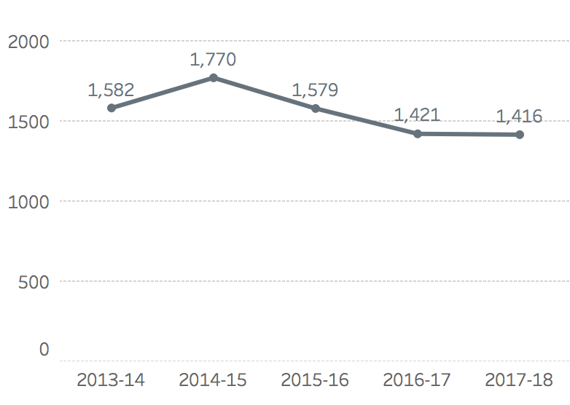

Note: These figures match those shown in Figure 79 of the LASPO Review on ‘acts of assistance’, once rounding is taken into account.

Base: All matters (7,768).

Figure 3.1 shows that the number of matters that have been closed declined from 1,770 in 2014/15 to 1,416 in 2017/18, although the number of calls, and cases referred to the specialist providers, increased from 2015/16 (as shown in the right hand column of Table 2.1, ‘CLA Specialist Data’). This is because the number and proportion of referrals to the specialist providers that have been determined not to be eligible to be taken on as matters has increased over the period. However, when assessing trends here and subsequently, it should be noted that some cases may have been taken on by specialist providers more recently and not yet been billed, so will not appear in the dataset.

Figure 3.2 Proportion of all referrals to the specialist providers taken on as matters, 2013/14 to 2017/18

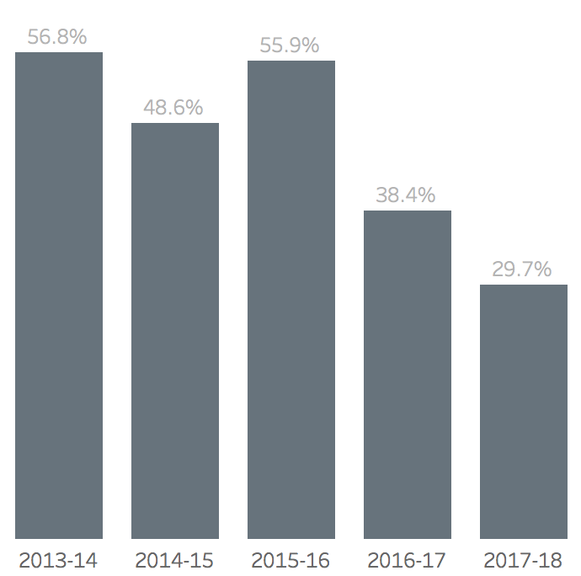

Base: All records (17,714).

Figure 3.2 shows that there has been a considerable fall in the proportion of referrals that result in matters, from 56.8% in 2013/14 to only 29.7% in 2017/18. However, as noted, some referrals in the later periods may still be open or have been closed in a different time period.

Table 3.3 Matters by financial eligibility

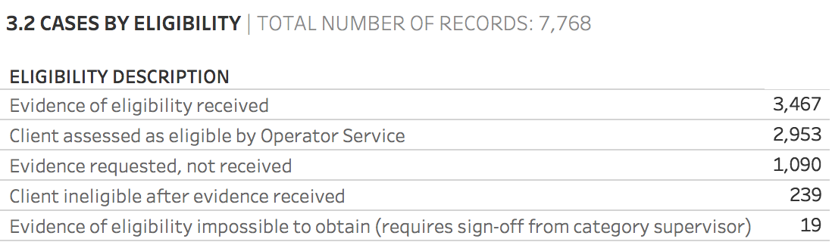

Note: Eligibility shown in Table 3.3 is at the point of file closure.

Base: All matters (7,768).

Table 3.3 shows that, in most matters, the client has been assessed as financially eligible by the operator service and/or evidence of eligibility has been received by the specialist provider. Matters where evidence has been requested but not received are analysed further in Section 11.

Figure 3.4 Matters by gender

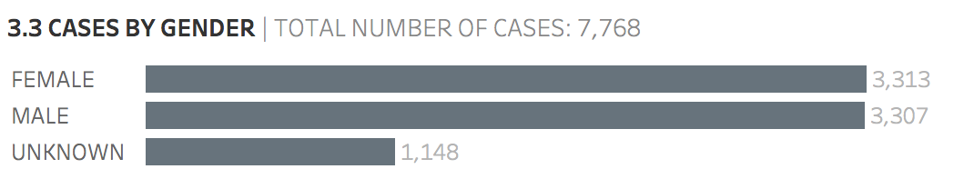

Base: All matters (7,768).

Figure 3.4 shows almost identical numbers of female and male contacts in matters for which gender data has been recorded. However, the high number of matters for which gender is unknown (1,148) makes it impossible to state categorically that no gender differences exist.

Figure 3.5 Matters by age

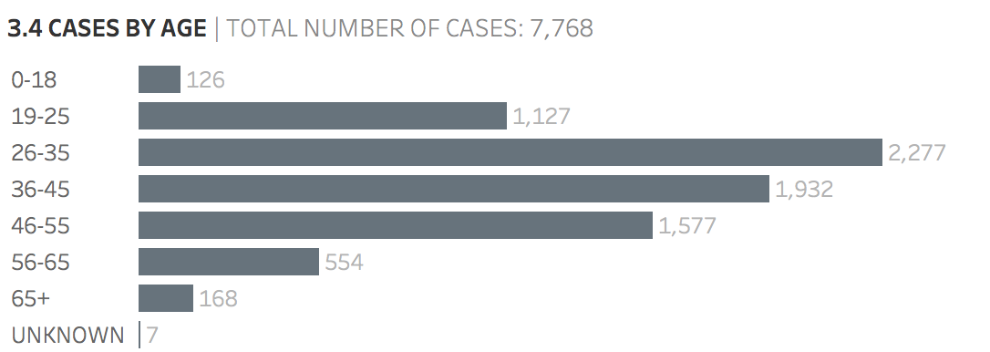

Base: All matters (7,768).

Figure 3.5 shows that the great majority of clients (89.0%) are aged between 19 and 55, with the largest group consisting of those aged 26 to 35. Unlike for gender, the age of the contact is known in almost all the cases.

Figure 3.6 Matters by ethnicity

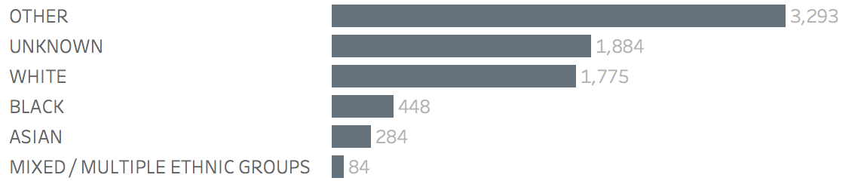

Base: All matters (7,768).

Figure 3.6 shows that the majority of matters have Unknown or Other ethnicity, suggesting that the data is not collected fully and systematically. Within the group of matters for which ethnicity information has been collected, the largest group is White people.

Figure 3.7 Matters by type

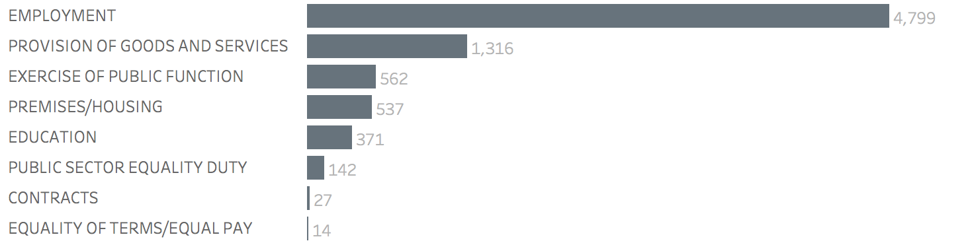

Base: All matters (7,768).

Figure 3.7 shows that the most common matter type is employment, accounting for 61.8% of all matters taken on. Provision of goods and services is the second most common matter type, accounting for 16.9% of all matters.

Figure 3.8 Matters by protected characteristic

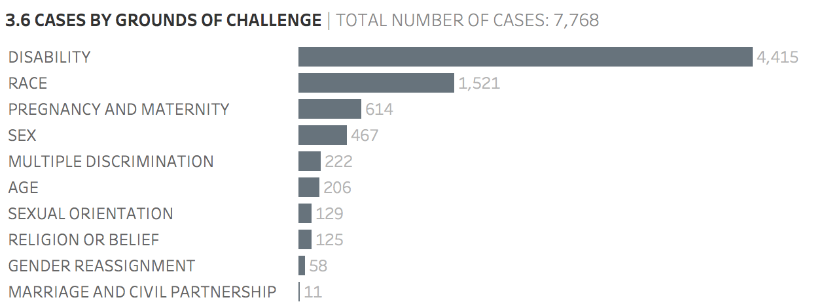

Base: All matters (7,768).

Figure 3.8 shows the number of matters by protected characteristic (the protected characteristic of the claim of discrimination rather than of the client). Figure 3.8 reveals that more than half of all matters (56.8%) are about issues relating to disability discrimination, and nearly a fifth (19.6%) are about issues relating to race discrimination. There are very few matters involving issues related to gender reassignment or to marriage and civil partnership. The number of matters relating to pregnancy and maternity and to sex are also lower than might have been anticipated.

1. Time spent and stage reached analysis

Section 4 relates to matters taken on only. Matters have been identified using the criteria laid out in Appendix A (Table A1.2). As noted in Section 2, this constitutes a total of 7,768 records.

The analysis carried out considers the time spent on matters, as well as the stage these matters reached.

The analysis also considers key metrics (as shown below) as well as age, gender, disability, ethnicity, matter type and ground of challenge. Only variables that have had an impact on matters are shown.

The categorisation of stages reached is laid out in Appendix A (Table A1.4).

Figure 4.1 Matters by stage

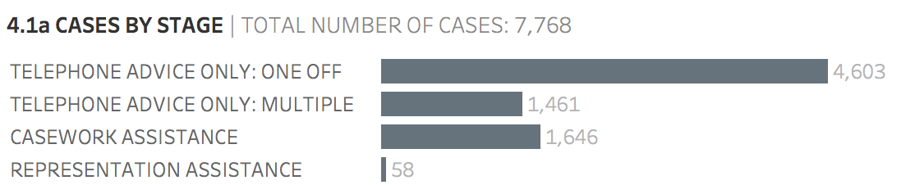

Base: All matters (7,768).

Figure 4.1 shows that the majority of clients (59.3%; 4,603 contacts) only receive one-off telephone advice. In total, 78.1% (6,064 contacts) of clients only received telephone advice without casework. Only 21.9% (1,704 contacts) of matters involved any casework. These matters are explored further below.

Figure 4.2 Representation assistance, 2013/14 to 2017/18

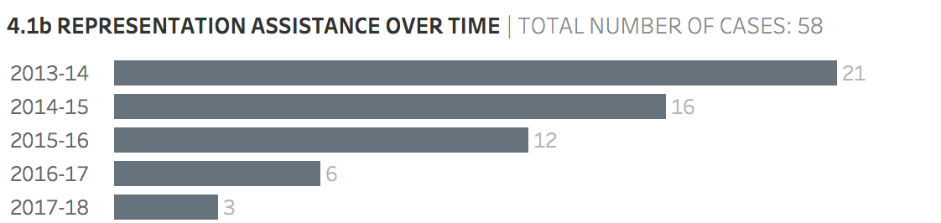

Base: All clients receiving representation assistance (58).

Figure 4.2 shows that the number of matters receiving representation assistance has steadily decreased over time since 2013/14. However, we understand that the code used for casework assistance may also be used in matters when assistance is given and proceedings have been issued; therefore these figures are not an accurate measure of the number of claims issued or assisted at court or in a tribunal.

Figure 4.3 Proportion of matters by stage and ethnicity

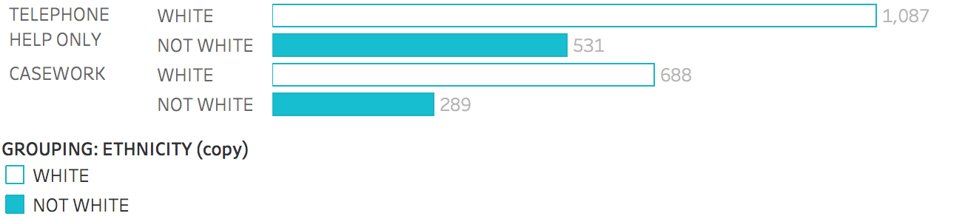

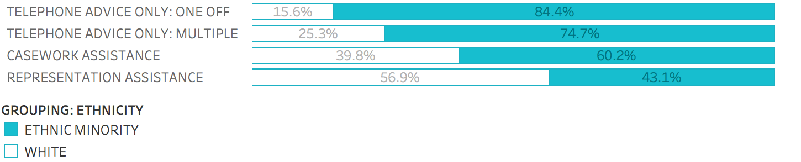

Base: All matters where ethnicity stated, excluding ‘Other’ and ‘Unknown’ responses (2,595).

Figure 4.3 shows the proportion of White clients and ethnic minority clients by stage. It shows that White clients made up 67.2% of those receiving telephone help only and 70.4% of those receiving casework assistance. While ethnic minority clients were therefore slightly less likely to receive casework assistance than White clients, these figures should be viewed with some caution due to the high number of respondents who do not state their ethnicity.

Figure 4.4 Proportion of matters by stage and disability

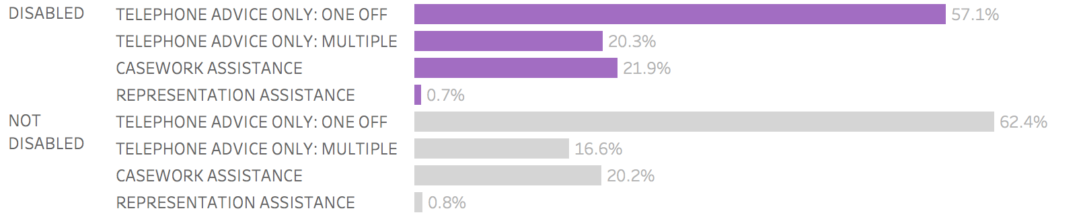

Base: All matters (7,768).

Figure 4.4 shows that disabled clients were slightly more likely to receive either casework assistance or representation assistance than non-disabled clients. Disabled clients were more likely to receive multiple instances of telephone advice than non-disabled clients, but less likely to receive one-off telephone advice only.

Figure 4.5 Mean hours spent on a matter, 2013/14 to 2017/18

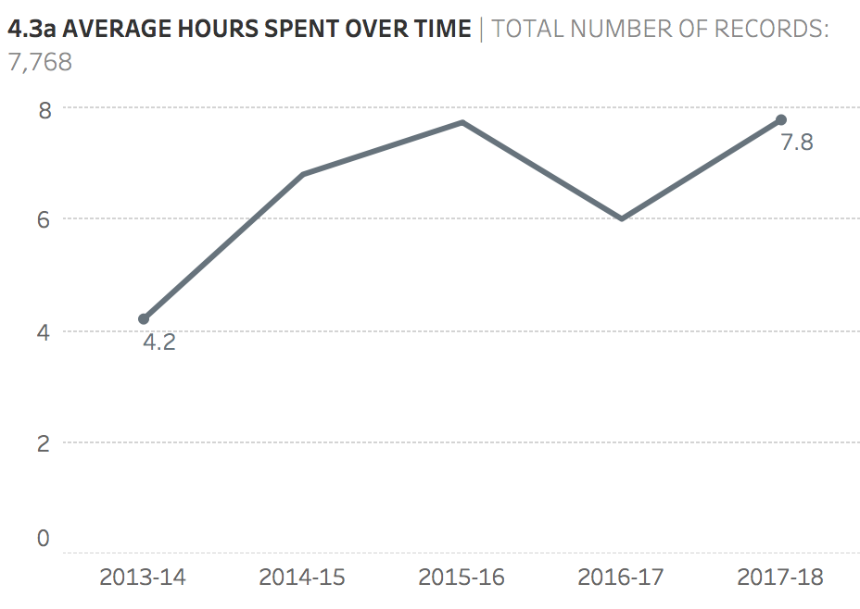

Base: All matters (7,768).

Figure 4.5 shows that the mean (average) hours spent on matters generally increased over time. In 2013/14, an average of 4.2 hours was spent on each case, compared with 7.8 hours in 2017/18. The increase in mean hours per case is perhaps to be expected as it is likely that a greater number of longer cases will have been billed in more recent years; this pattern is due to larger outliers (that is, matters for which a much higher number of hours has been spent) in the later years. The median (shown in Figure 4.6) is therefore a more reliable indicator of the time spent.

Figure 4.6 Median hours spent on a matter, 2013/14 to 2017/18

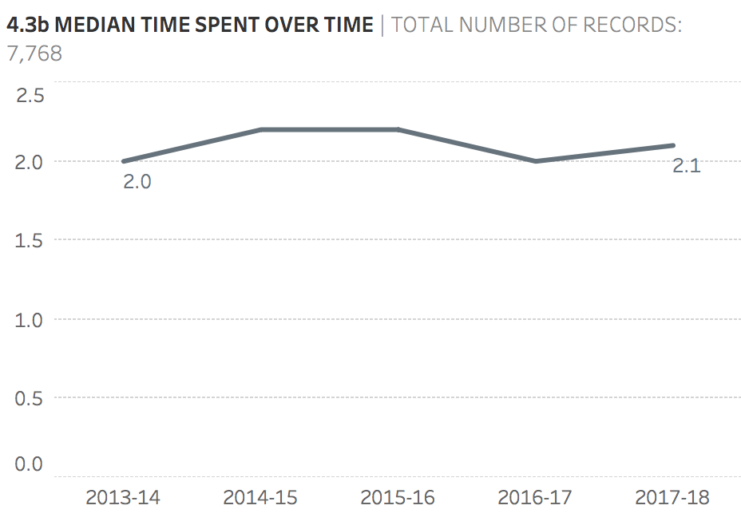

Base: All matters (7,768).

As Figure 4.6 shows, the pattern is much more stable when analysing the median time spent as opposed to the mean time spent.

Figure 4.7 Median hours spent on a matter by stage, 2013/14 to 2017/18

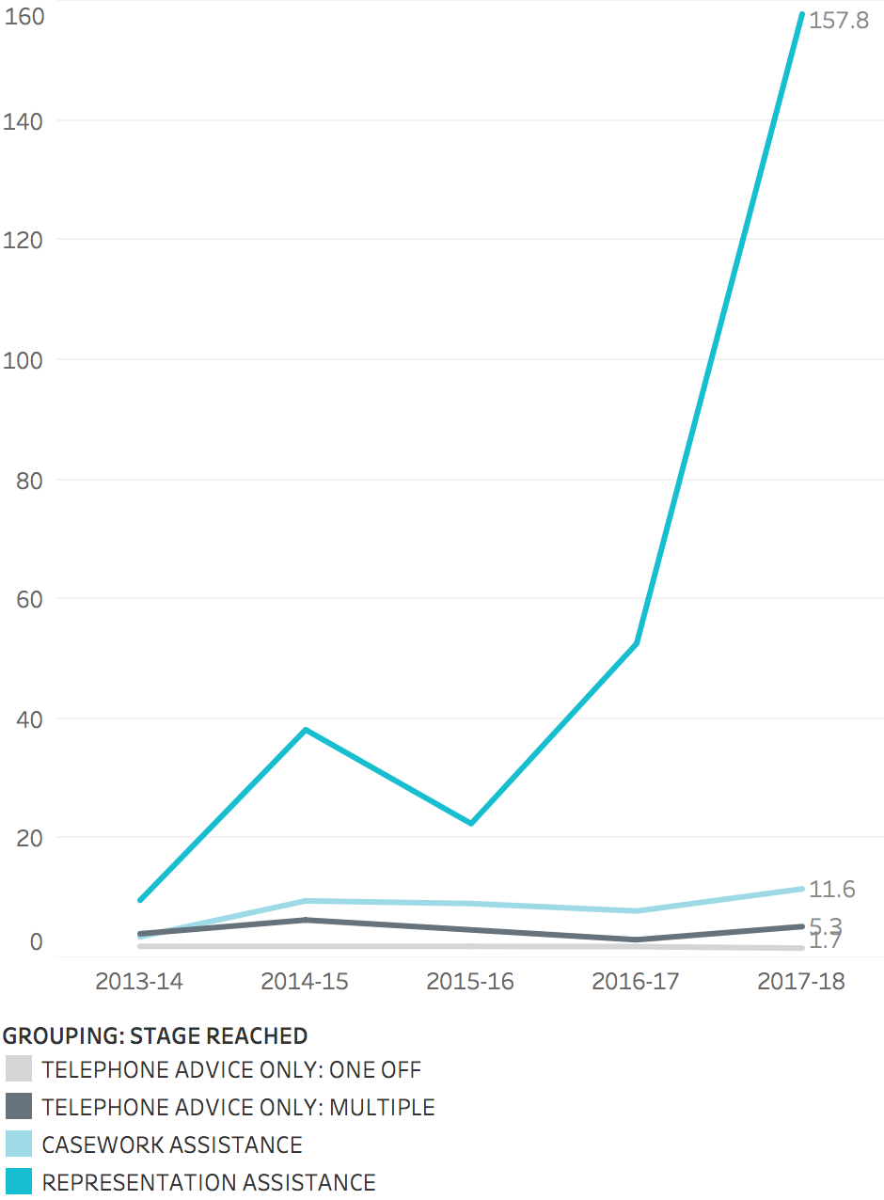

Base: All matters (7,768).

Unsurprisingly, the time spent on matters increases as the matter reaches each subsequent stage. Figure 4.7 shows that the median time spent on matters that received representation assistance in 2017/18 was 157.8 hours, a significant increase from 2013/14. In contrast, the median time spent on matters that received casework assistance in 2017/18 was only 11.6 hours; the median time spent on those that received multiple telephone advice was 5.3 hours; and the median time spent on those that received one-off telephone advice only was 1.7 hours.

Figure 4.8 Distribution of advice time spent on matter

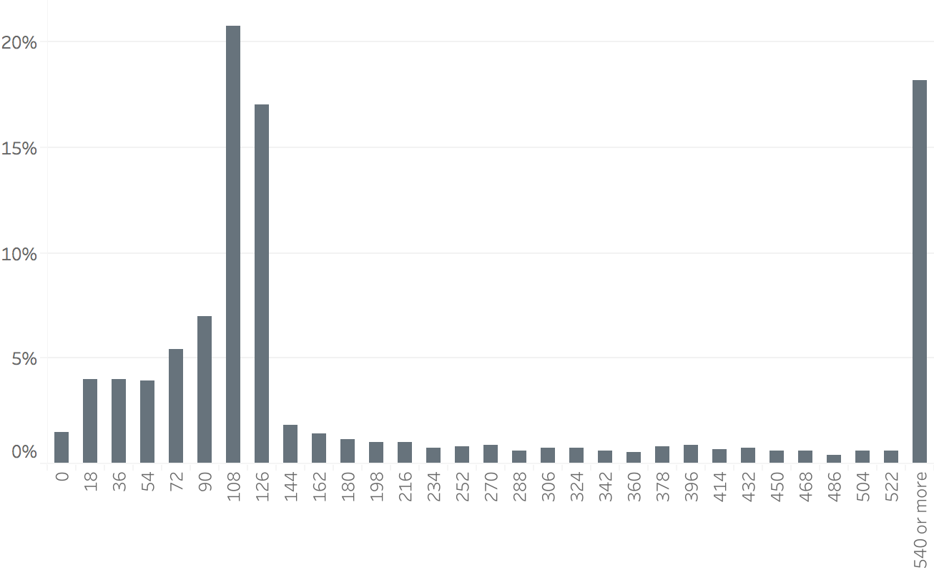

Base: All matters (7,768).

Figure 4.8 shows that the most common amount of time spent by CLA specialists on advice was either approximately two hours (just under two hours (108 minutes) or just over two hours (126 minutes)) or nine hours or more (540 or more minutes).

1. Positive outcome analysis

Section 5 relates to matters taken on only. Matters taken on have been identified using the criteria laid out in Appendix A (Table A1.2). As noted in Section 2, this constitutes a total of 7,768 records.

The analysis carried out considers the outcome of the case, paying particular attention to matters that have a positive outcome.

The analysis also considers key metrics (as shown below) as well as age, gender, disability, ethnicity, matter type and ground of challenge. Only variables that have had an impact on matters are shown.

The categorisation of outcome is shown in detail in Figure 5.1 and in grouped categories in Figure 5.2. It should be noted that there are different ways in which the outcome codes can be categorised. The approach we have adopted lists all the codes that indicate a positive substantive benefit has been obtained for the client as ‘substantive positive’. This category includes outcomes where compensation has been obtained and where reasonable adjustments have been made. We have shown code QK (which denotes ‘client advised and better able to manage their affairs’) separately because it is the most common code used and may – or may not – mean that the client was able to achieve a positive substantive outcome (such as compensation). Other outcomes include that the client ceased to give instructions and that the case stopped on the advisor’s recommendation.

Table 5.1 Number of matters by outcome (detailed results)

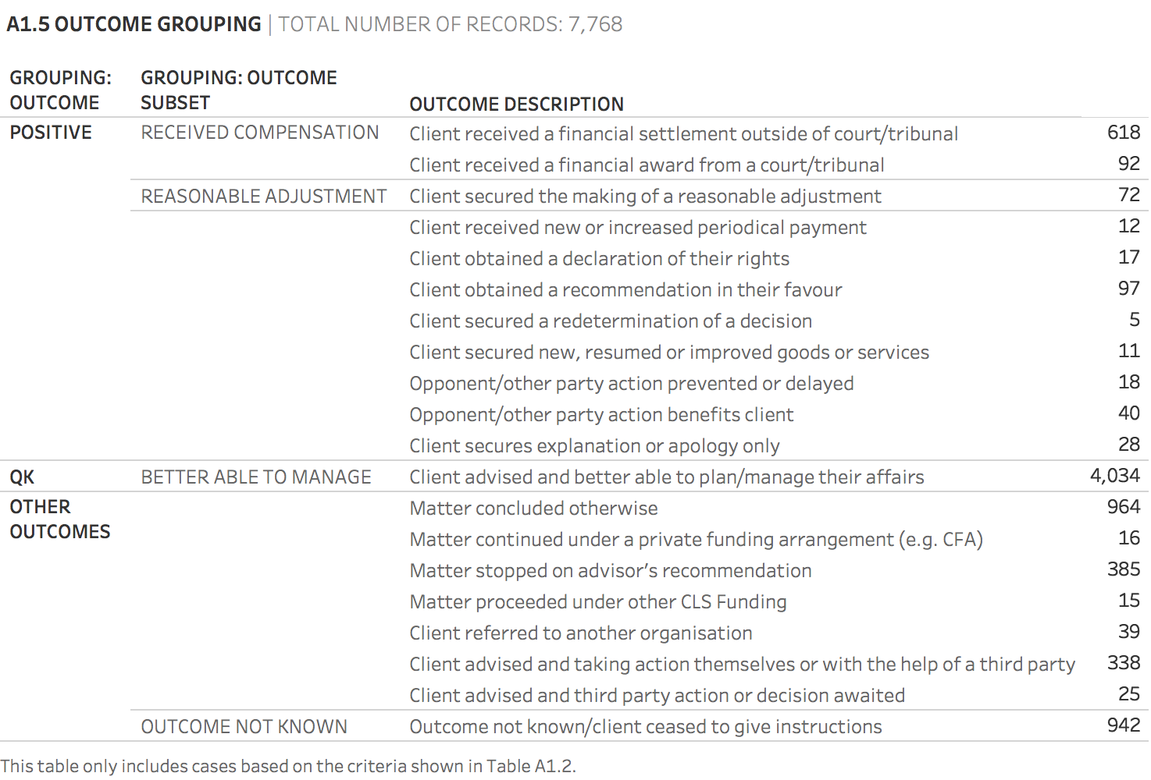

Note: We recognise that ‘Client received new or increased periodical payment’ also involves receipt of money by the client, but we have distinguished this circumstance from compensation.

Base: All matters (7,768).

Figure 5.2 Matters by outcome (summary results)

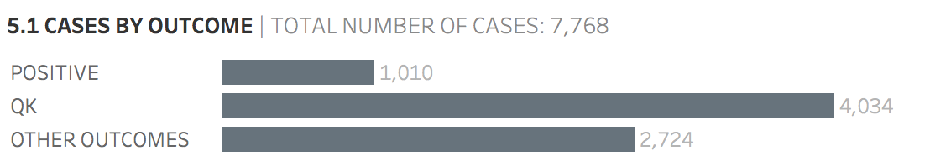

Note: ‘Positive’ in Figure 5.2 means ‘substantive positive’, as explained above.

Base: All matters (7,768).

Figures 5.1 and 5.2 show that the majority of matters (51.9%) have an outcome of QK. A substantive positive outcome can be identified in 1,010 matters (13.0%), although (as noted above) some of those recorded under QK may also have had a positive outcome; 1,010 therefore represents the minimum number of matters that resulted in a positive outcome. Only 92 (1.2%) matters resulted in a financial award by a court or tribunal. A further 618 (8.0%) resulted in a financial settlement outside of a court or tribunal, and only 72 (0.9%) resulted in a reasonable adjustment.

According to the CLA data, only 0.2% of cases proceed to funding under a Public Funding Certificate (PFC), which can fund representation at court. The detailed analysis provided in the accompanying PFC report, ‘Civil legal advice: analysis of Public Funding Certificate data’, suggests this figure may be under-reported and the true figure is 0.6% (or a little over 1 in 200 matters).

Figure 5.3 Matters by outcome, 2013/14 to 2017/18

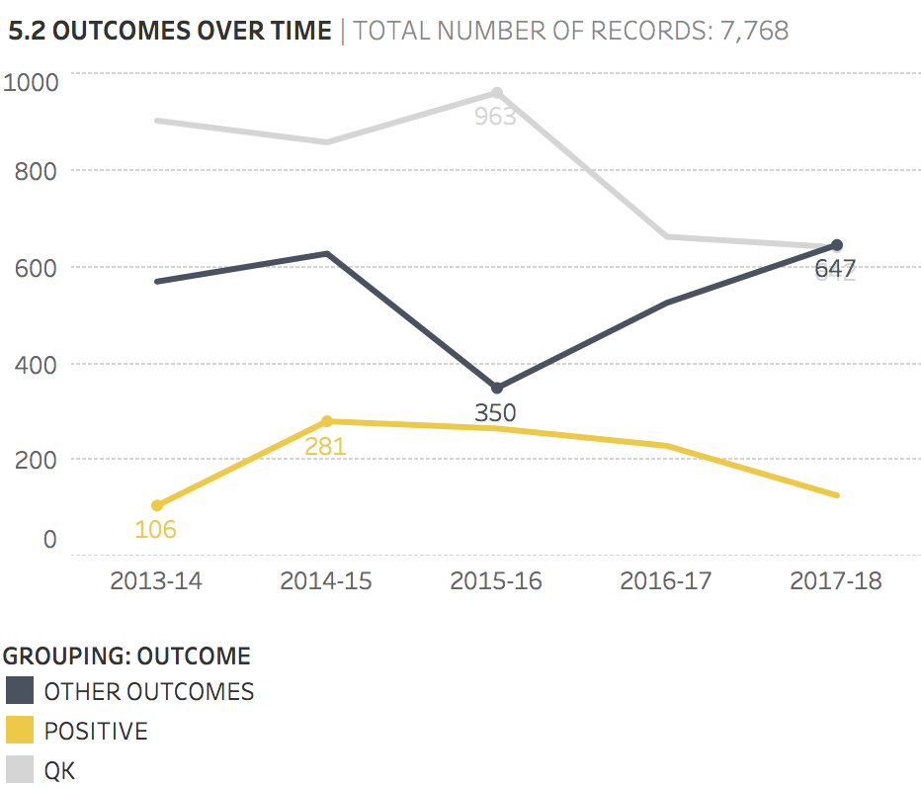

Note: ‘Positive’ in Figure 5.3 means ‘substantive positive’, as explained above.

Base: All matters (7,768).

Figure 5.3 shows that, while the majority of matters have an outcome of QK, the number of these matters has decreased over time. Conversely, the number of matters with ‘other outcomes’ has shown an increase of 85% (from 350 to 647) between 2015/16 and 2017/18. The number of substantive positive outcomes has fluctuated over time, peaking at 281 in 2014/15 and falling to 127 in 2017/18. The increase in other outcomes over time is due to various reasons. Either the matter was stopped on the recommendation of the advisor, or the outcome was not known, or the client ceased to give instructions.

Figure 5.4 Median hours spent on the case by outcome, 2013/14 to 2017/18

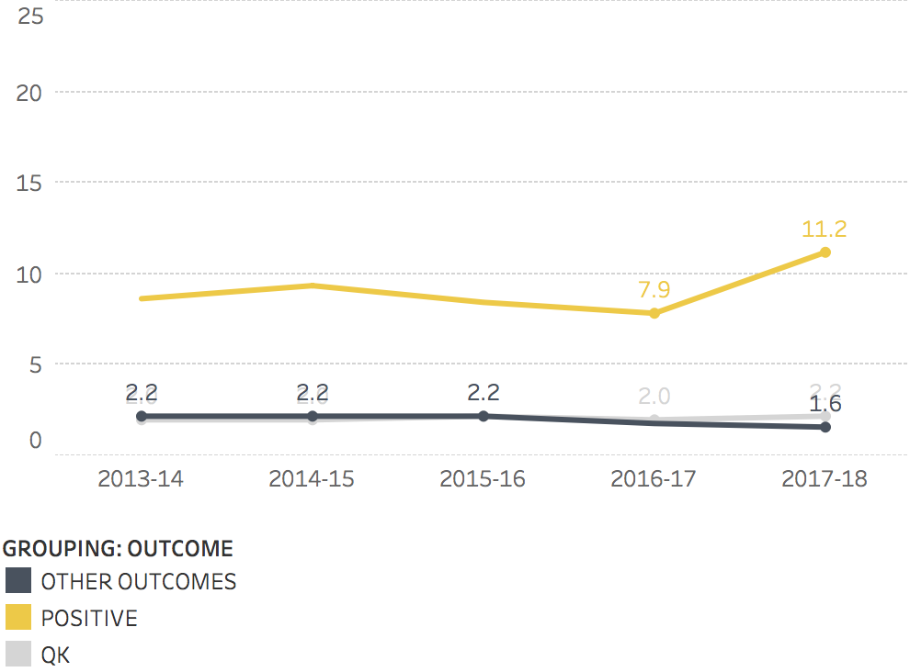

Note: ‘Positive’ in Figure 5.4 means ‘substantive positive’, as explained above.

Base: All matters (7,768).

Matters with a positive outcome have more time spent on them on average (Figure 5.4). Other outcomes and QK outcomes have a similar amount of median time spent.

Figure 5.5 Proportion of matters achieving a substantive positive outcome by stage reached

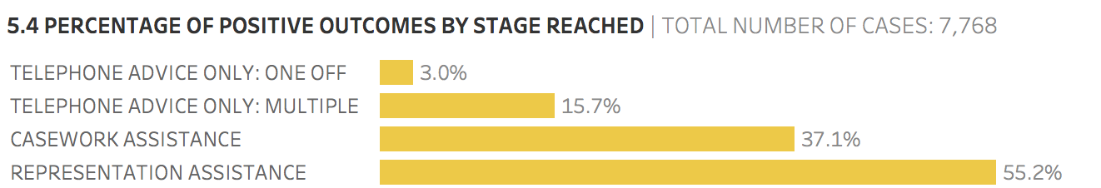

Base: All matters (7,768).

The further the stage reached, the larger the proportion of matters that have a substantive positive outcome. As shown in Figure 5.5, 3% of matters that receive one-off telephone advice only and 15.7% that receive multiple telephone advice only have a substantive positive outcome. This means that just 6.1% of matters that only receive telephone advice have a substantive positive outcome compared with 37.7% of matters that receive either casework or representation assistance.

Figure 5.6 Proportion of matters achieving a substantive positive outcome by matter type

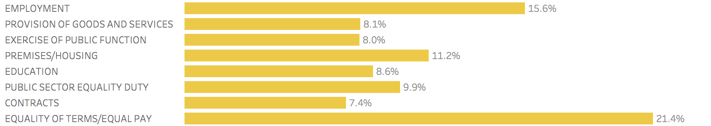

Base: All matters (7,768).

Figure 5.6 shows the proportion of matters achieving a substantive positive outcome by matter type. The figure is sorted in order of volume of matters. For example, while the category ‘Equality of terms/equal pay’ has the smallest number of matters (14), 21.4% of those matters received a positive outcome. ‘Employment’, the most common matter type, has a higher than average proportion of positive outcomes (15.6% compared with an average of 11.3%).

Figure 5.7 Proportion of matters achieving a substantive positive outcome by protected characteristic

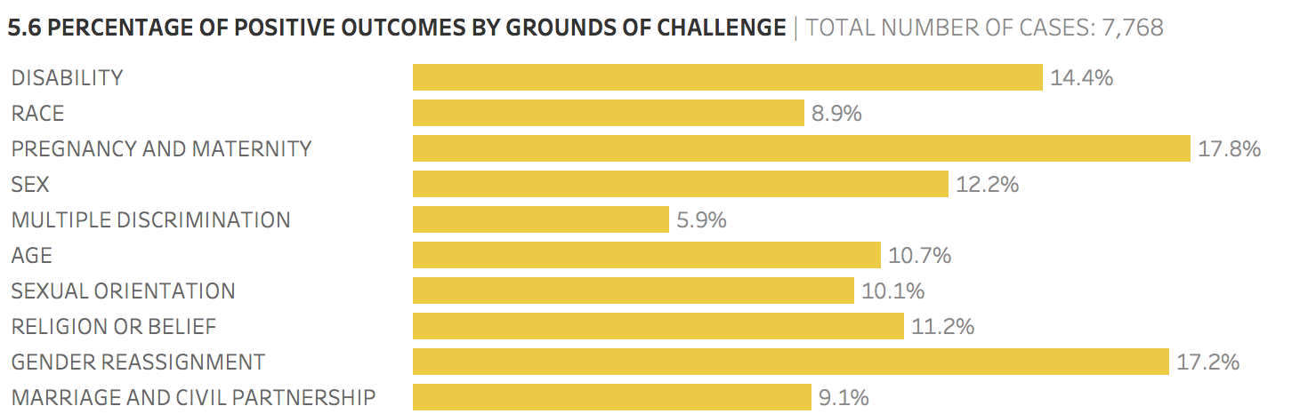

Base: All matters (7,768).

Figure 5.7 shows the proportion of positive outcomes by the protected characteristic that forms the ground of the claim. The pattern is broadly similar across the majority of protected characteristics. However, pregnancy and maternity, gender reassignment, and (although to a lesser extent) disability have a higher proportion of positive outcomes than average, and multiple discrimination has a particularly low proportion.

Figure 5.8 Proportion of matters achieving a substantive positive outcome by ethnicity

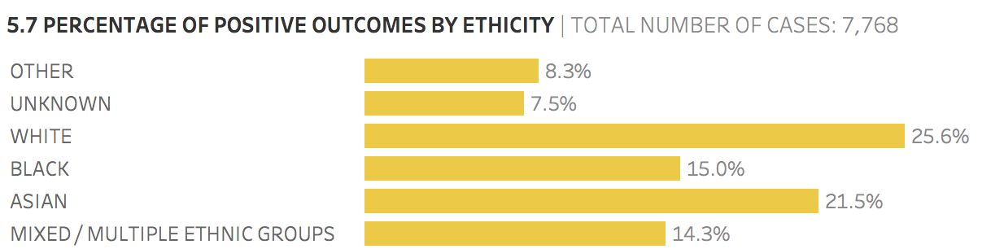

Base: All matters (7,768).

Figure 5.8 shows that the proportion of White clients receiving a substantive positive outcome is higher than the proportion of ethnic minority clients receiving a substantive positive outcome. When the figures for Black, Asian and Mixed / Multiple ethnic groups are combined, 17.2% of ethnic minority clients (140 out of 816) receive a substantive positive outcome. This compares with 25.6% of White clients (455 out of 1,775).

1. Disability analysis

Section 6 relates to matters taken on only. Matters have been identified using the criteria laid out in Appendix A (Table A1.2). This constitutes a total of 7,768 records.

The analysis carried out considers disabled and non-disabled clients. The categorisation of disability is based on the clients’ self-declarations and the ground of challenge. The categorisation of disability is further outlined in Appendix A (Table A1.3).

The analysis also considers key metrics (as shown below) as well as age, gender, ethnicity, matter type and ground of challenge. Only variables that have had an impact on matters are shown.

Figure 6.1 Matters by disability

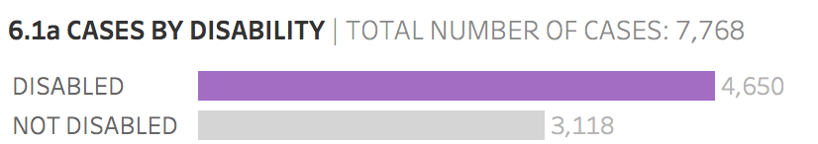

Base: All matters (7,768).

Figure 6.1 shows that the majority of matters (59.9%) involve a client who can be classified as being disabled according to the criteria set out in Table A1.3. It should be noted that this figure differs markedly from those given by the LASPO Review, which does not seek to classify ‘unknown’ clients as either disabled or non-disabled; the LASPO Review reports that 40% of Discrimination clients reported being disabled.

**Figure 6.2 Matters by disability breakdown**

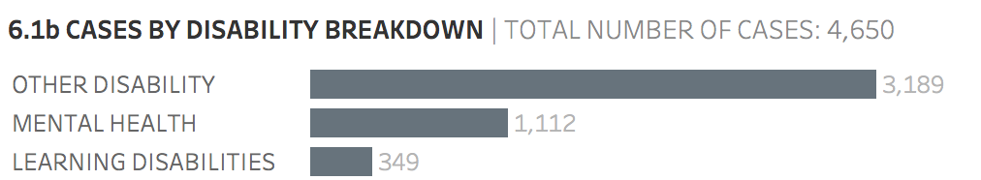

Base: All matters where client identified as disabled (4,650).

Figure 6.2 shows that, of the 4,650 disabled clients, 23.9% and 7.5% respectively stated they had either a mental health condition or learning disability.

Figure 6.3 Matters by disability, 2013/14 to 2017/18

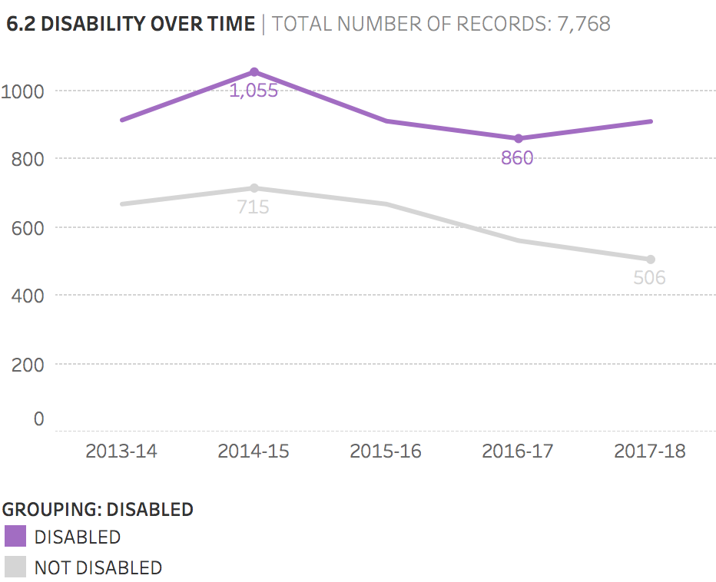

Base: All matters (7,768).

Figure 6.3 shows that the number of non-disabled clients has steadily decreased over time, whereas the number of disabled clients has fluctuated.

Figure 6.4 Proportion of matters with a disability, 2013/14 to 2017/18

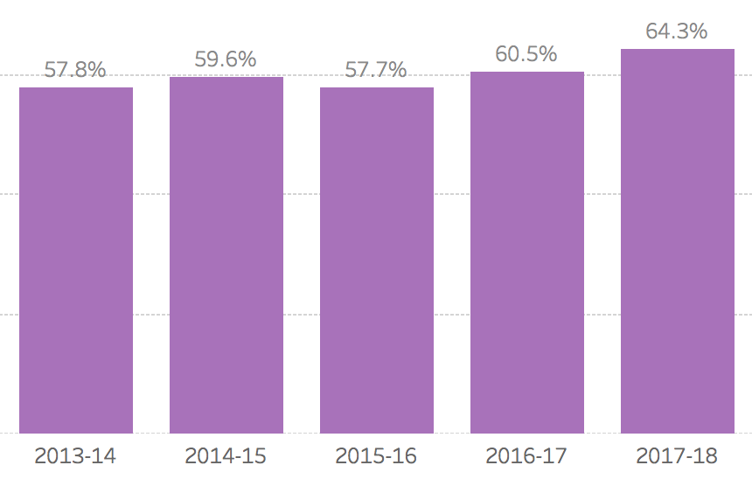

Base: All matters (7,768).

Figure 6.4 shows that, between 2015/16 and 2017/18, the number of matters involving a disabled client has increased from 57.7% to 64.3%.

Figure 6.5 Median time spent on case by disability, 2013/14 to 2017/18

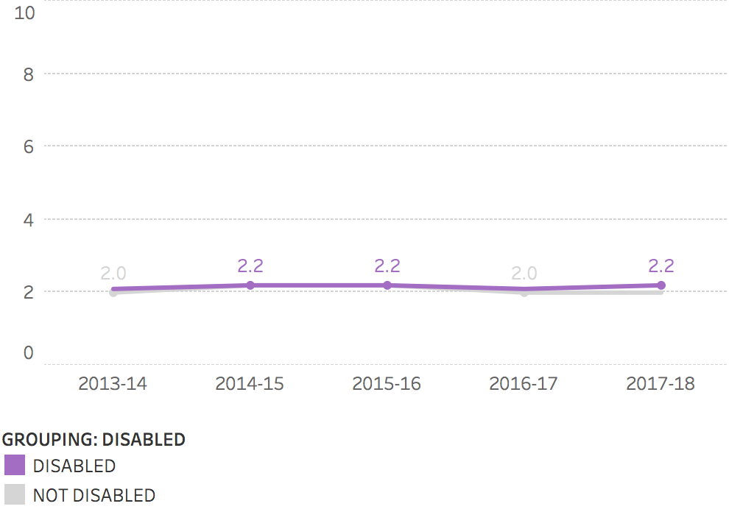

Base: All matters (7,768).

Figure 6.5 shows that the median time spent on each case is very similar for disabled and non-disabled clients and that the median time spent has not changed significantly over time.

Figure 6.6 Proportion of adjustment/adaptations by disability

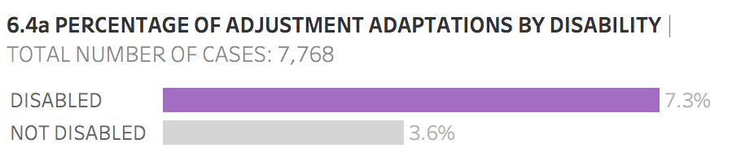

Note: The ‘Disabled’ figure is based on the total number of cases with an adequate adjustment relating to people who are classed as disabled (341) divided by the total number of people who are classed as disabled in Figure 6.1 (4,650). The ‘Not disabled’ figure comes from the total number of cases with an adequate adjustment relating to people who are not classed as disabled (111) divided by the total number of people who are not disabled in Figure 6.1 (3,118).

Base: All matters (7,768).

Specialist providers are required to make service adaptions and reasonable adjustments for clients who require them, whether they are disabled or non-disabled. These adaptions and adjustments may include the use of an interpretation service, text phone, postal advice, accessible correspondence format, and any other reasonable adjustments required under the Equality Act 2010.

Figure 6.6 shows that only 7.3% of disabled clients receive an adjustment or adaptation. As would be expected, the proportion of non-disabled clients who receive an adjustment or adaption is lower.

Table 6.7 Proportion of adjustment or adaptations provided by type of disability

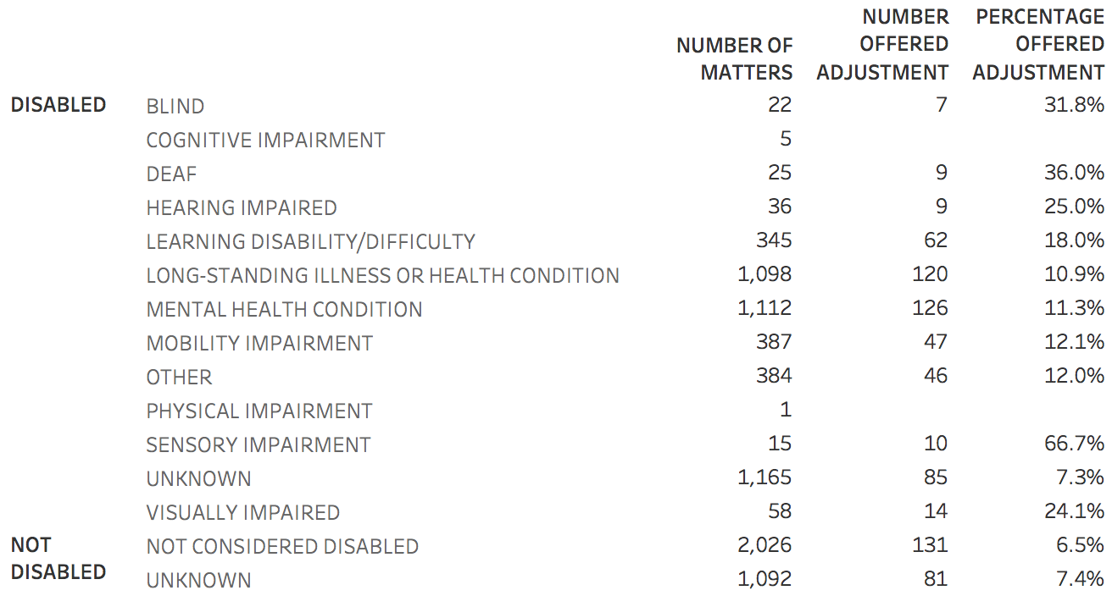

Notes: It is unclear whether the unknown code denotes a person whose type of disability is unknown or about whom it is unknown whether they are disabled or not.

In the circumstances we have included those who are recorded as unknown but who brought a disability claim as a proxy to indicate they are disabled. There could be a small number of non-disabled people who, for example, brought a claim of discrimination by association, but we believe that our approach captures the number of disabled clients more accurately than an approach that treats this group as non-disabled.

‘Unknown’ in the *disabled* section (1,165 matters) therefore consists of people whose ground of challenge was disability but who were recorded as unknown in terms of their disability. ‘Unknown’ in the *not disabled* section (1,092 matters) consists of people whose challenge was a ground other than disability and were recorded as unknown in terms of their disability.

Base: All matters (7,771). This table includes the three exempted cases discussed in Section 10.

Figure 6.7 shows that disabled people with a sensory impairment are most likely to receive an adjustment adaptation, with 66.7% receiving an adjustment adaptation.

An analysis of whether the adjustments have an impact on the outcomes shows that the proportion of disabled clients who have a substantive positive outcome is very similar whether or not an adjustment was made.

1. Language difficulties analysis

Section 7 relates to matters taken on only. Matters have been identified using the criteria laid out in Appendix A (Table A1.2). This constitutes a total of 7,768 records.

Table 7.1 Matters with adjustment adaptations

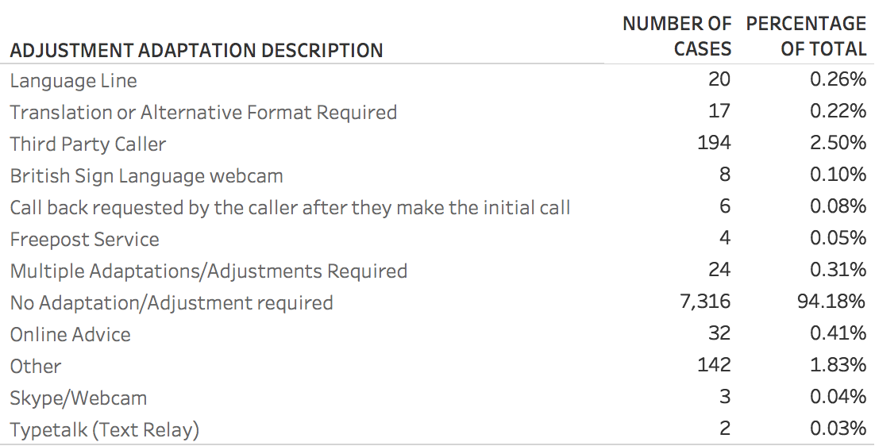

Base: All matters (7,768).

Table 7.1 shows that only a very small number of these matters (20) included the use of a language line; this figure represents 0.3% of all matters. Even fewer matters (17) included the use of a translator.

Some clients may use a friend or relative if they have language difficulties and this may have resulted in their matter being categorised as a third-party caller. If this assessment is correct, there are slightly more clients (194; 2.5% of all matters) that use this adjustment adaptation.

1. Face-to-face analysis

We were unable to identify callers who received a face-to-face service using the specific dataset provided by the LAA for the purposes of this report. However, the LAA has informed us that the figures given in the following parliamentary answer on the same topic are accurate. These figures show that only 16 clients received face-to-face advice in the Discrimination category of law between 2013 and 2017. The LAA has also informed us that the figure for 2017/18 is 2 clients, producing a total of 18 clients who received face-to-face advice between 2013 and 2018, out of a total of 7,768 matters.

The parliamentary question (reference 111874) posed was: ‘[H]ow many of the calls received by the Mandatory Civil Legal Advice Gateway in each year since 2013 have been referred for face-to-face advice, for each category of advice[?]’ (posed on 7 November 2017). The following is a relevant extract of the answer provided by Dominic Raab on 17 November 2017:

The table below shows the number of clients in each of the categories who either received face-to-face advice via Civil Legal Advice (CLA) or who were referred to legal aid face-to-face advice providers. Please note that in the category of Debt a Civil Legal Advice Provider will make a referral to a suitable Legal Aid Provider if they identify a client as needing face-to-face advice. In the categories of Discrimination and Education the CLA Specialists are contracted by the Legal Aid Agency to also provide Face-to-Face advice when needed.[3]

Table 8.1 Clients referred/advised face-to-face, 2013/14 to 2016/17[4]

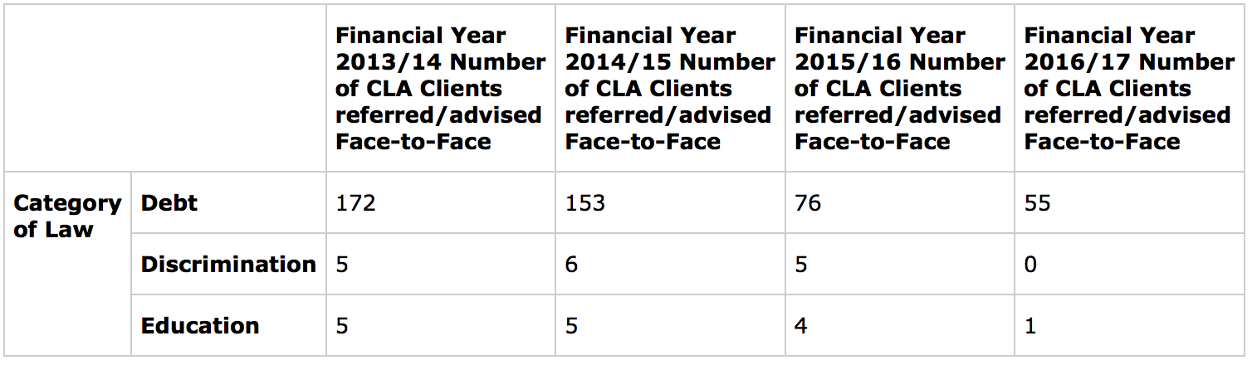

Note: Parliamentary answer, 17 November 2017; no data provided for 2017/18.

1. Referral source analysis

Section 9 relates to matters taken on only. Matters have been identified using the criteria laid out in appendix A (Table A1.2). As noted in Section 2, this constitutes a total of 7,768 records.

The analysis carried out considers the referral source of the client; that is, how they identified the CLA service.

Figure 9.1 Matters by source of referral

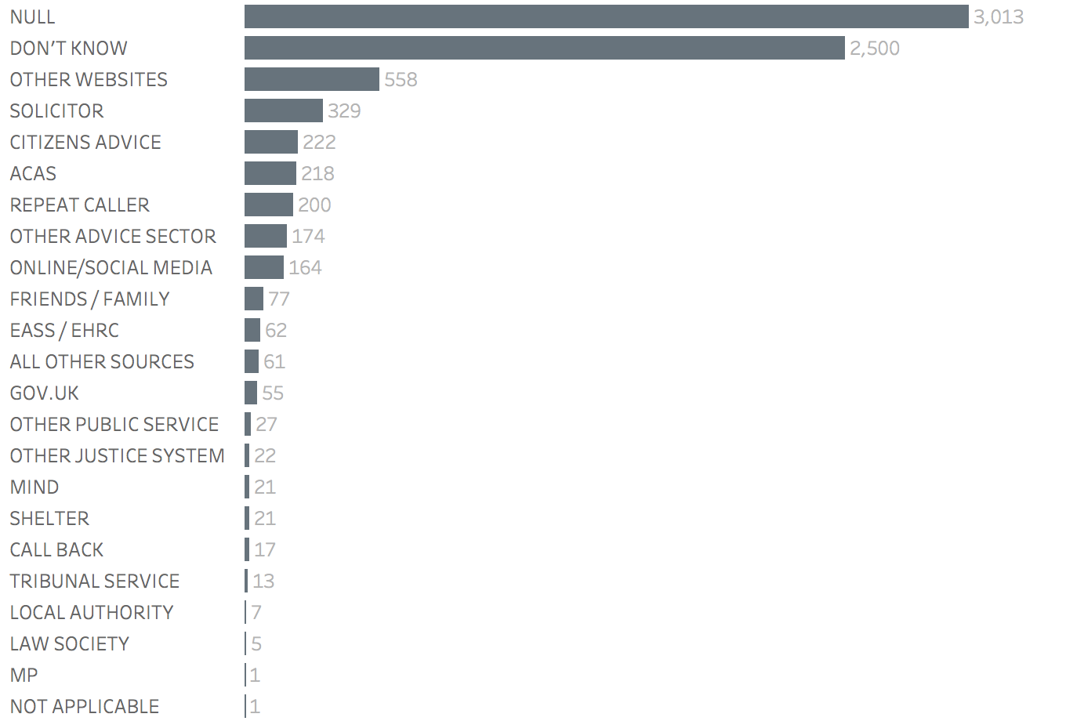

Base: All matters (7,768).

Figure 9.1 shows that the referral source for the majority of clients is not known. The most common referral sources for those who provided an answer were websites, solicitors, Citizens Advice, ACAS and other advice sector organisations. Only 55 clients stated that they obtained details of CLA from the Government’s website (gov.uk).

Figure 9.2 Number of unknown referrals, 2013/14 to 2017/18

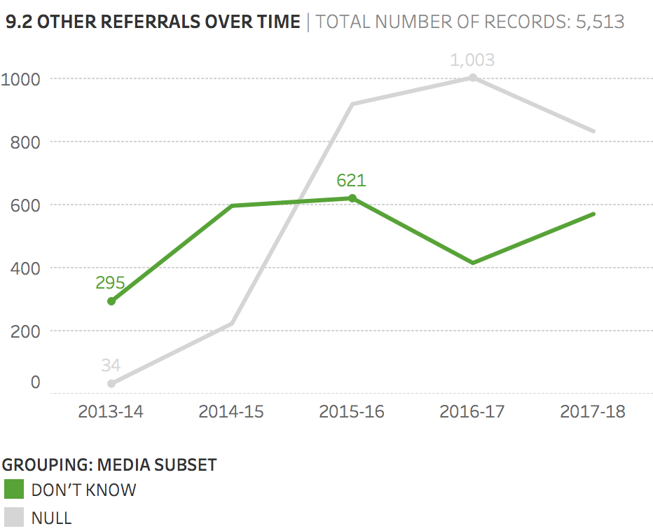

Base: All other referrals (5,513).

Figure 9.2 shows the two responses given by the largest number of clients (no answer given or ‘Don’t know’) over time. The figure shows that the ‘Null’ response has increased dramatically over time from only 34 giving no response in 2013/14 to 1,003 giving no response at the peak in 2016/17.

1. Exempted cases analysis

Section 10 relates to exempted matters only, which constitute a total of only three records. Exempted matters are matters for which the client does not have to use the mandatory telephone gateway. In Discrimination matters the client may instruct a specialist provider directly, which will mean that their matters are recorded in the LAA dataset. Exempted matters include those involving:

* clients who have been deprived of their liberty (including through prison, detention centre or secure hospital)
* clients who are children (defined as being people under the age of 18), and

clients who have previously been assessed by the CLA as requiring face-to-face advice in a mandatory category of law, or have accessed face-to-face advice within the last 12 months and are seeking further help to resolve a linked problem from the same face-to-face provider.

The clients in all three exempted matters are classed as disabled. Figure 10.1 indicates the other remaining features of these matters.

Table 10.1 Exempted matters by reason, matter type and protected characteristics

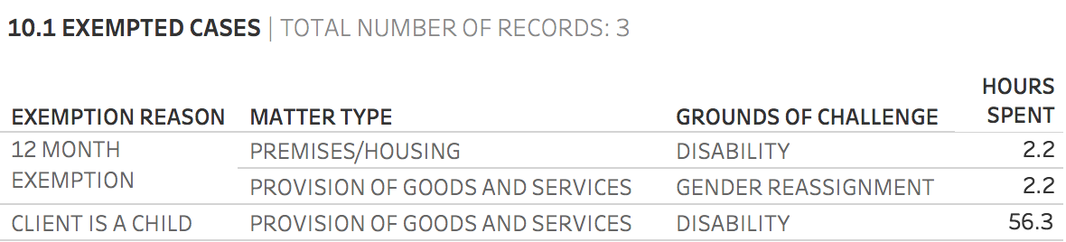

Base: Exempted matters (3).

1. Failed to supply evidence analysis

Section 11 relates to matters that were taken on and in which evidence of financial eligibility was requested but not supplied. This constitutes a total of 1,090 records. An ambiguity in the codes means that some of the matters in this group may have concluded without evidence needing to be provided. It is assumed that often these matters would have been closed as a result of the client failing to supply the evidence.

The analysis carried out considers key metrics (as shown below) as well as age, gender, disability, ethnicity, matter type and ground of challenge. Only variables that have had an impact on matters are shown.

Figure 11.1 Matters in which client failed to supply evidence, 2013/14 to 2017/18

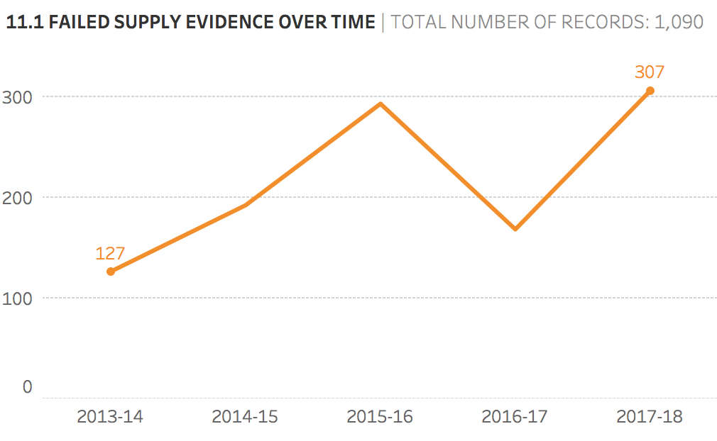

Base: Clients failing to supply evidence (1,090).

Figure 11.1 shows that the number of matters in which the client failed to supply evidence has generally increased over time, from 127 in 2013/14 to 307 in 2017/18.

Figure 11.2 Matters in which client failed to supply evidence by disability

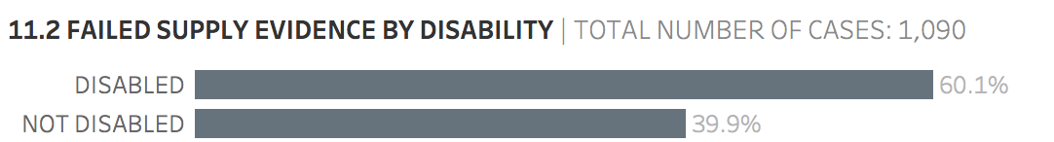

Base: Clients failing to supply evidence (1,090).

Figure 11.2 shows that the client can be classified as disabled in 60.1% of matters that failed to supply evidence. This proportion is very similar to the overall proportion of clients who can be classified as disabled (59.9%).

Figure 11.3 Matters in which client failed to supply evidence by disability, 2013/14 to 2017/18

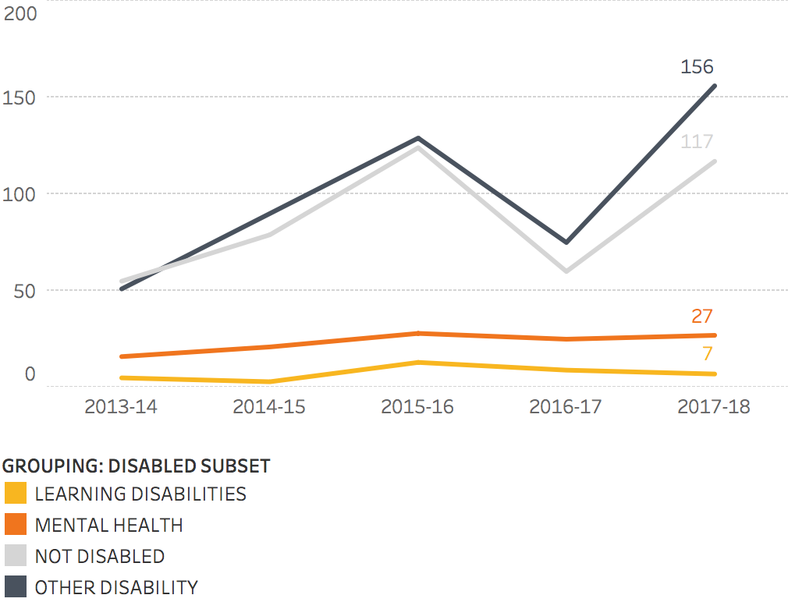

Base: Clients failing to supply evidence (1,090).

Figure 11.3 shows that the number of disabled clients who failed to supply evidence and either had learning disabilities or mental health conditions remained broadly the same between 2013/14 and 2017/18.

Figure 11.4 Matters in which client failed to supply evidence by matter type

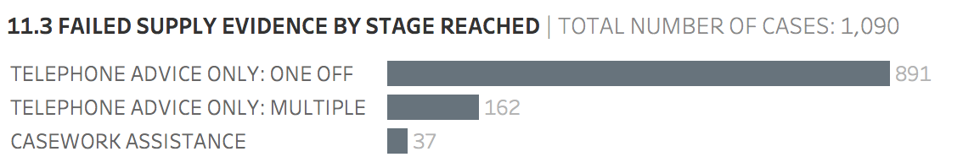

Base: Clients failing to supply evidence (1,090).

Figure 11.4 shows that the majority of matters (891) in which the client failed to supply evidence involved only one-off telephone advice. One possibility is that the matter was closed after the initial telephone advice due to a failure by the client to provide evidence. Another possibility is that the matter was resolved before The client was required to provide evidence. This category equates to 81.7% of all the relevant matters.

12. Determinations

Sections 3 to 11 of the report focus on the 7,768 matters in the dataset; that is, cases taken on by a specialist provider. Section 12 shifts the focus to determinations; that is, the 9,946 cases that fail to meet the eligibility tests referred to in Section 1. Together, matters and determinations account for 17,714 records in the dataset, with determinations making up 56.1% of all records.

The analysis carried out considers key metrics (as shown below) as well as age, gender, disability, ethnicity, matter type and ground of challenge. Only variables that have had an impact on determinations are shown.

Figure 12.1 Total number of records by determinations and matters, 2013/14 to 2017/18

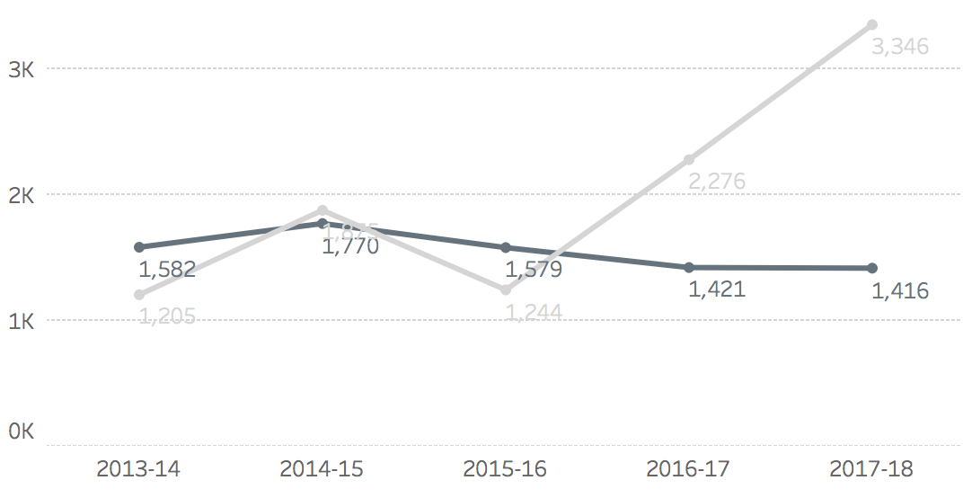

Note: Determinations are shown in light grey and matters in dark grey.

Base: All records in dataset (17,714).

Figure 12.1 shows the breakdown of determinations and matters over time. The number of determinations increased significantly between 2014/15 and 2017/18, from 1,875 to 3,346. The number of matters taken on declined from 1,770 to 1,416 in the same period.

Figure 12.2 Determinations as a proportion of all records, 2013/14 to 2017/18

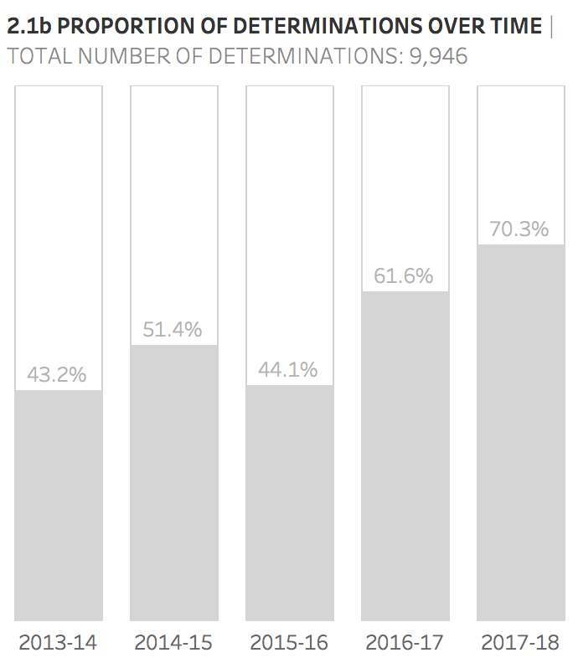

Note: Determinations are indicated by the dark shading.

Base: All records in dataset (17,714).

Figure 12.2 shows that the proportion of determinations has increased from 43.2% of all records in 2013/14 to 70.3% of all records in 2017/18.

Figure 12.3 Determinations by reason

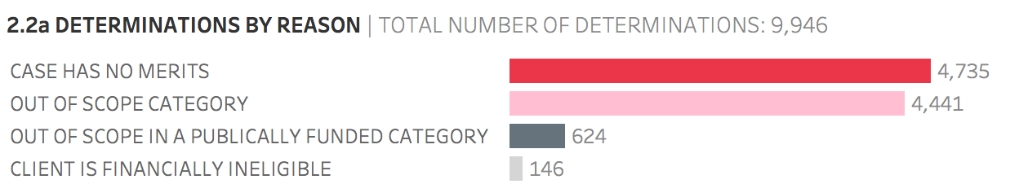

Base: All determinations (9,946).

Figure 12.3 shows the determinations by the reason for determination. The great majority of determinations (92.3%) were assessed as either having no merit or being out of scope. Of the total determinations, 6.3% were deemed out of scope in a publicly funded category and 1.5% were determined because the client was assessed as financially ineligible.

Figure 12.4 Determinations by reason, 2013/14 to 2017/18

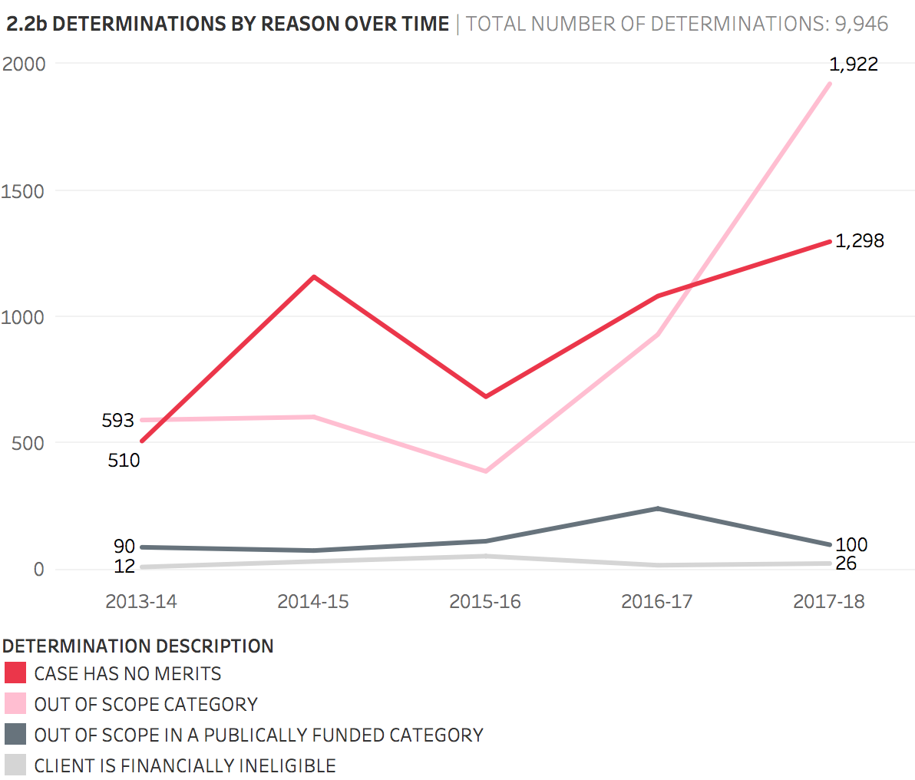

Base: All determinations (9,946).

Figure 12.4 illustrates the determinations by reason over time and shows two distinct trends between 2013/14 and 2017/18. The number of determinations in which the client was either financially ineligible or the case was out of scope in a publicly funded category largely remained steady over the period, but the number of determinations within the two larger categories (case has no merits or out of scope category) steadily increased. This increase was particularly marked for the out of scope category, for which determinations increased from 593 in 2013/14 to 1,922 in 2017/18.

Figure 12.5 Determinations by matter type

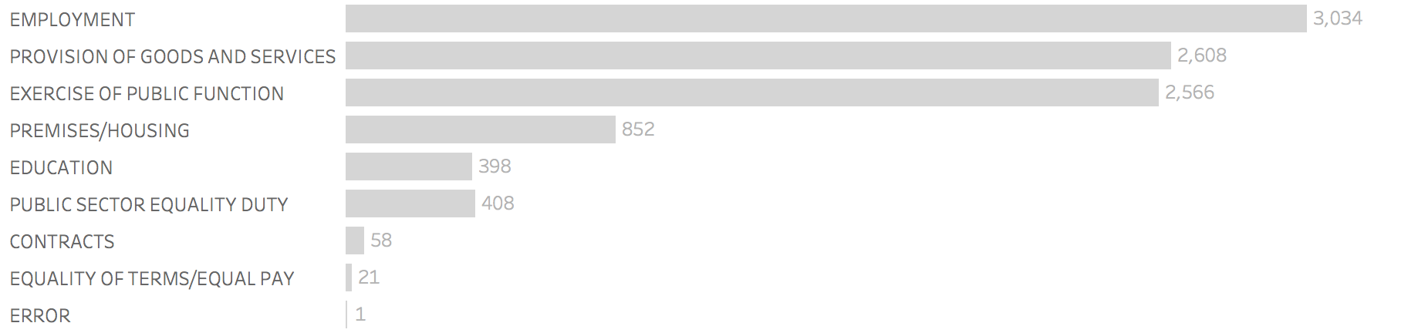

Base: All determinations (9,946).

Figure 12.5 shows the number of determinations by matter type. The most common matter type is employment, followed by provision of goods and services, and then exercise of public function, both of which have a similar number of determinations. These three categories account for 82.5% of all determinations.

Figure 12.6 Proportion of all records of a particular matter type that are determinations

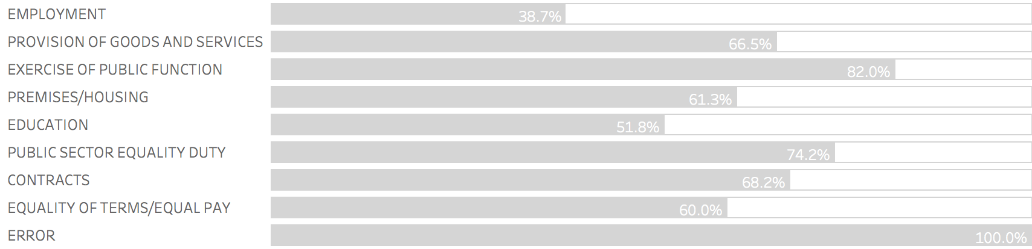

Note: Determinations are indicated by the dark shading. The error response in Figure 12.5 has been omitted.

Base: All records (17,714).

Although the largest number of determinations involve employment claims, Figure 12.6 shows that only 38.7% of contacts for which the matter type is employment result in determinations, and the majority of contacts for this category result in matters. However, for all other matter types, most contacts result in determinations rather than matters; the highest proportion exists for records involving the exercise of public function, for which 82.0% of contacts result in determinations.

Figure 12.7 Determinations by protected characteristic

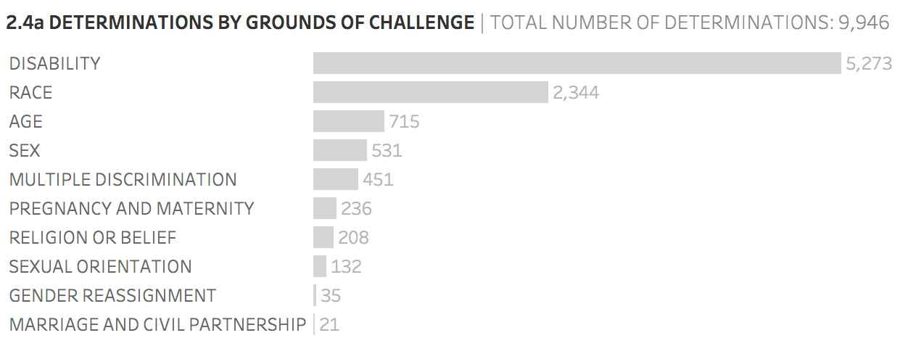

Base: All determinations (9,946).

Figure 12.7 shows the number of determinations by the protected characteristic of the claim if discrimination. The figure reveals that more than half of all determinations (53.0%) relate to disability discrimination and nearly a quarter (23.6%) relate to race discrimination. There are far fewer determinations relating to any other protected characteristic or for multiple discrimination. In comparison, 56.8% of matters relate to disability discrimination and 19.6% to race discrimination (Figure 3.8).

Figure 12.8 Proportion of all records that are determinations by protected characteristic

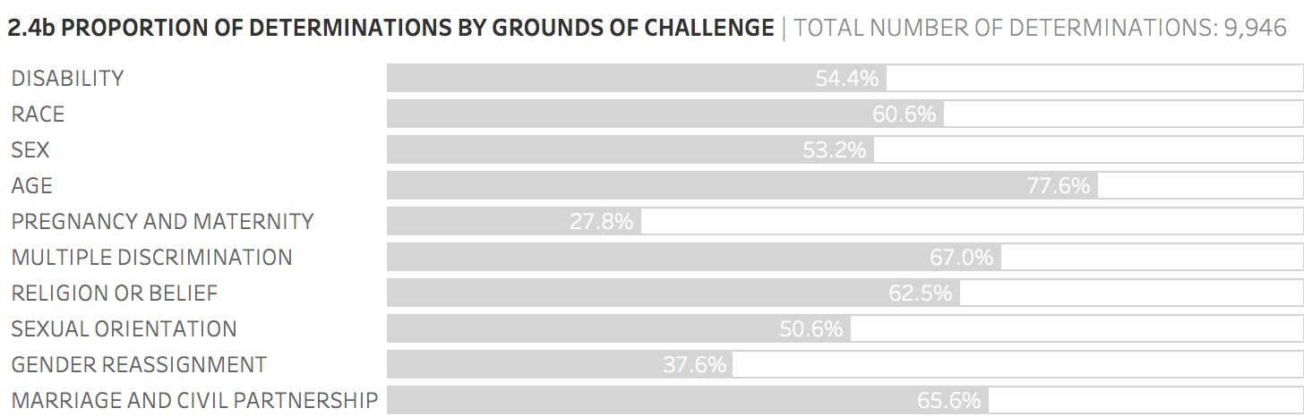

Note: Determinations are indicated by the dark shading.

Base: All records (17,714).

Figure 12.8 shows that there is considerable variation in the proportion of records that relate to different protected characteristics resulting in either a matter or a determination. The proportion of disability discrimination records that result in determinations is very similar to the overall proportion of all records that result in determinations shown above (54.4% compared to 56.2%). A much higher proportion of records relating to age result in determinations (77.6%). The proportion of pregnancy and maternity records that result in determinations is much lower than average (27.8%).

Figure 12.9 Determinations by ethnicity

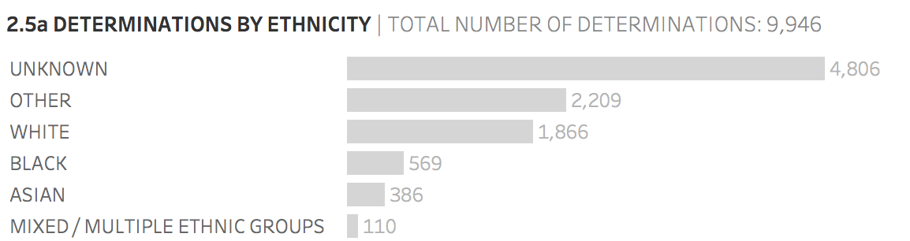

Base: All determinations (9,946).

Figure 12.9 shows that the majority of determinations have Unknown or Other ethnicity, which suggests that the data is not collected fully and systematically. When information on determinations for specific groups has been collected, the largest group emerges as White people.

Figure 12.10 Proportion of all records that are determinations by ethnicity

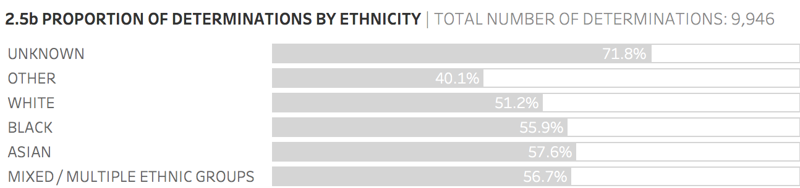

Note: Determinations are indicated by the dark shading.

Base: All records (17,714).

Figure 12.10 shows that the majority (71.8%) of Unknown ethnicity records relate to determinations and not matters. With the exception of the Other category, the remaining ethnicity categories have a roughly equal split between determinations and matters and align with the overall percentage of records that result in determinations.

13. Conclusions

This report assesses the provision of legal aid for discrimination claims via the mandatory Civil Legal Advice (CLA) telephone gateway. The key findings are outlined below.

Matters and determinations

* Between 2013/14 and 2017/18, there were approximately 33,000 (6,600 per annum) calls to CLA about discrimination, of which nearly 18,000 (3,500 per annum) were referred on by the operator service to a specialist provider.
* Of these 18,000 calls, 7,768 matters were taken on (equivalent to approximately 1,550 per annum).
* More than half (56.1%) of contacts referred on to a specialist provider resulted in ‘determinations’; that is, these cases were determined by the specialist provider not to be eligible for assistance.
* The proportion of calls referred through to specialist providers taken on as matters declined from 56.8% in 2013/14 to only 29.7% in 2017/18. Even with the proviso that some cases may have been taken on by specialist providers nearer the end of the dataset’s time period and not have been billed (and therefore may not appear in the dataset), the decline in the proportion of calls that are taken on as matters is still striking.
* The number of matters taken on has also fallen from 1,770 in 2014/15 to 1,416 in 2017/18.
* The majority of matters relate to employment and a higher than average proportion of employment referrals are taken on as matters (61.3%). By contrast, 82.0% of contacts involving the exercise of public function result in determinations and are not taken on as matters.
* The majority of matters are concerned with disability discrimination (56.8%) and a further 19.6% with race discrimination. There are very few matters involving issues related to gender reassignment or marriage and civil partnership. The number of matters relating to pregnancy and maternity and to sex are also lower than might have been anticipated.

The great majority of determinations (92.3%) were assessed as either having no merit or being out of scope.

Telephone advice, casework and face-to-face advice

* The great majority of matters receive one-off telephone advice only. In total, 78.1% of clients received telephone advice and only 21.9% of matters involved any casework.
* Only 7.3% of disabled clients received a reasonable adjustment or adaptation.
* Only a very small number of matters (20) were given the use of a language line. This relates to 0.3% of all matters. Similarly, even less (17) used a translator. Some clients may use a friend or relative if they have language difficulties and this may have resulted in the matter being categorised as a third-party caller. If this assessment is correct, there are slightly more clients (194 and 2.5% of all matters) that use this adjustment adaptation.

Only 18 clients received face-to-face advice in the Discrimination category of law between 2013/14 and 2017/18.

Outcomes

* It is difficult to give a precise figure about the proportion of matters that result in a positive outcome for the client. This is because the majority of matters are categorised as ‘client advised and better able to manage their affairs’ (QK) often without any casework being undertaken on their behalf. It is not possible to know how many of these people went on to secure a substantively positive outcome such as compensation, or a finding that they suffered discrimination, without the benefit of further legal aid.
* Only 1.2% of cases resulted in a financial award by a court or tribunal. A further 8.0% resulted in a financial settlement and only 0.9% of cases resulted in a reasonable adjustment. In total, 13.0% of cases result in a substantive positive outcome.
* According to the CLA data, only 0.2% of cases proceed to funding under a Public Funding Certificate (PFC), which can fund representation at court. The detailed analysis in the accompanying PFC report (‘Civil Legal Advice: analysis of Public Funding Certificate data) suggests this figure may be under-reported and the true figure is 0.6% (or a little over 1 in 200 matters).
* The further the stage of the process that is reached, the more likely it is that an outcome will be positive. Matters that receive either casework assistance or representation are much more likely to result in a substantive positive outcome than those which receive telephone advice only.
* Matters with a positive outcome have more time spent on them by the specialist provider than the average.
* The proportion of positive outcomes is broadly similar across protected characteristics. However, cases relating to pregnancy and maternity, gender reassignment and (although to a lesser extent) disability, have a higher than average proportion of positive outcomes, whereas a particularly low proportion of multiple discrimination cases have positive outcomes.

A higher proportion of White than ethnic minority clients receive a substantive positive outcome (25.6% compared with 17.2%).

Protected characteristics of contacts

* Three-fifths of clients (59.9%) can be classified as disabled on the basis of the criteria set out in Section 6. Of the 4,650 disabled clients, 23.9% and 7.5% respectively stated they had either a mental health condition or learning disability.
* The dataset shows that men and women are almost equally likely to have their cases taken on, but the high proportion of matters for which the client’s gender is not known means this conclusion can only be tentative.
* The majority of contacts are aged between 19 and 55; very few are aged under 19 or over 65.

The large number of matters where ethnicity is classified as Unknown or Other means that it is not possible to state whether ethnic minorities are under-represented.

Awareness of website

* Only 55 contacts stated that they obtained details of CLA from the Government’s website (gov.uk).

Data limitations

* The quality of some data, for example relating to matter type and age of contact, is very high. However, there are significant gaps in the data collected on ethnicity, disability and gender, which makes it harder to draw firm conclusions.
* It is not possible categorically to state the number of people who receive representation.

Appendix A: Grouping criteria

The following tables detail the groupings that have been used throughout the report. Each grouping has been referred to in the relevant section where relevant.

Table A1.1 Exemption grouping

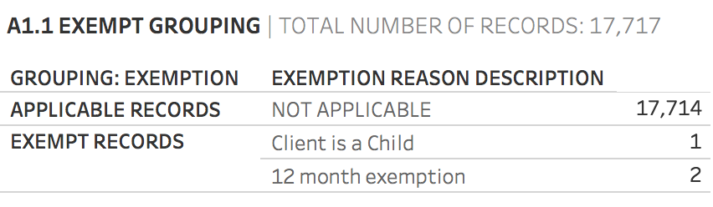

Base: All records (17,717).

Table A1.2 Determinations grouping

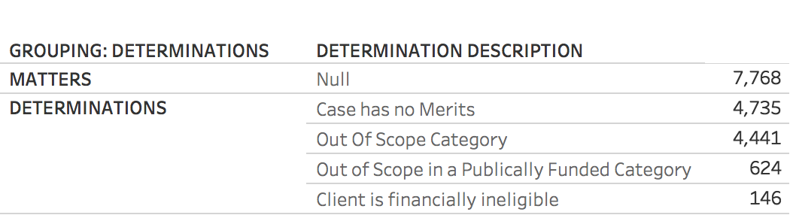

Base: All records excluding exemptions (17,714).

Table A1.3 Disability grouping

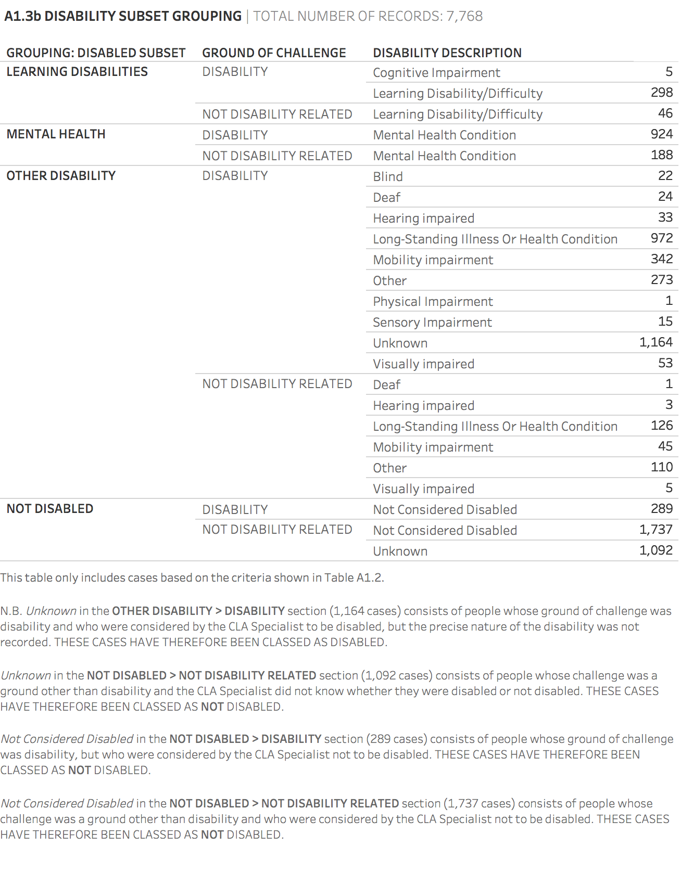

Notes: It is unclear whether the unknown code denotes a person whose type of disability is unknown or about whom it is unknown whether they are disabled or not.

In the circumstances we have included those who are recorded as unknown but who brought a disability claim as a proxy to indicate they are disabled. There could be a small number of non-disabled people who, for example, brought a claim of discrimination by association, but we believe that our approach captures the number of disabled clients more accurately than an approach that treats this group as non-disabled.

‘Unknown’ in the disabled section (1,165 matters) therefore consists of people whose ground of challenge was disability but who were recorded as unknown in terms of their disability. ‘Unknown’ in the not disabled section (1,092 matters) consists of people whose challenge was a ground other than disability and were recorded as unknown in terms of their disability.

Base: All matters (7,768).

Table A1.4 Stage reached grouping

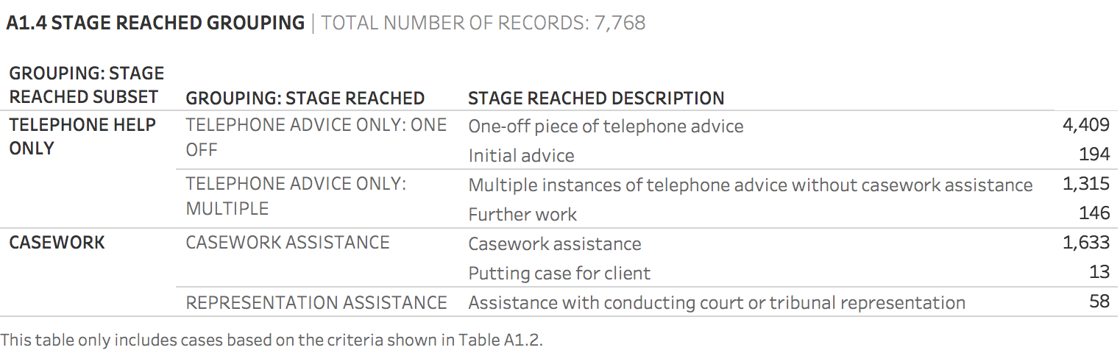

Base: All matters (7,768).

**Table A1.5 Outcome grouping**



Notes: We recognise that ‘Client received new or increased periodical payment’ also involves receipt of money by the client, but we have distinguished this circumstance from compensation.

Base: All matters (7,768).

Table A1.6 Media grouping

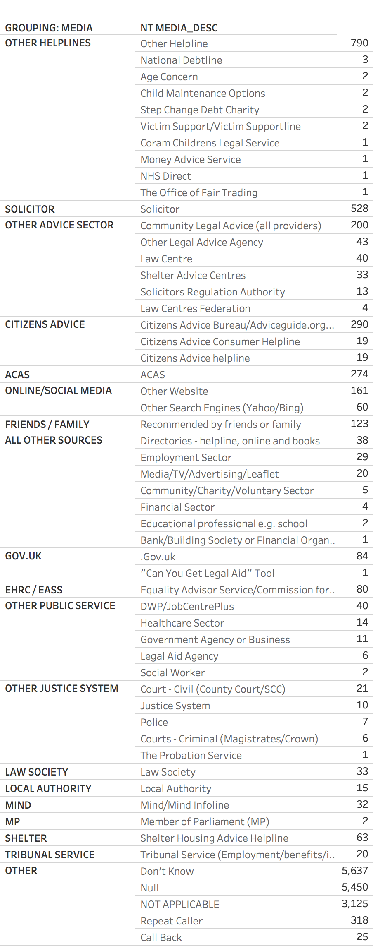

Base: All records excluding exemptions (17,714).

Table A1.7 Ethnicity grouping

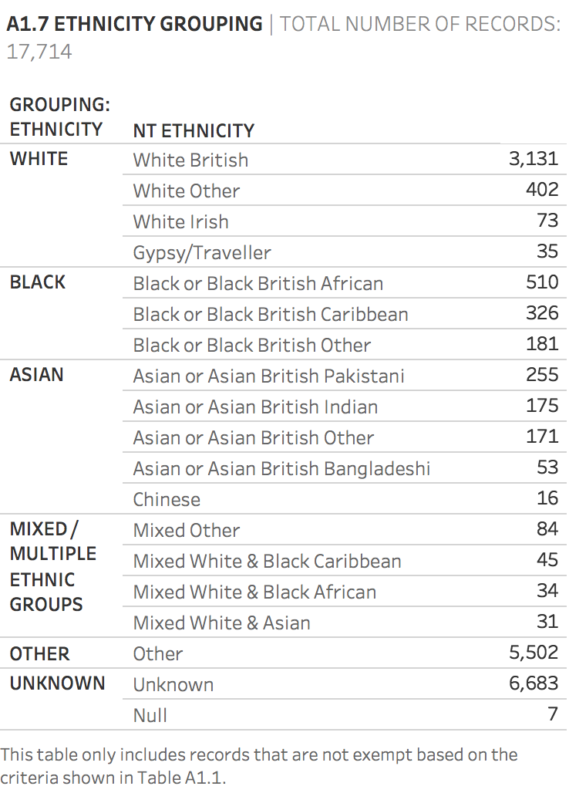

Base: All records excluding exemptions (17,714).

Appendix B: Data quality

The following figures indicate the fields used within our analysis that have unknown or blank categories. The figures indicate the volume of unknown or blank fields for all matters (regardless of whether the case was taken on or was a determination). However, we have indicated the volume of matters taken on that these missing fields affect, as a higher volume will have the greater impact on our analysis. It should be noted that, when information has not been recorded for gender, ethnicity and disability, this may simply reflect the fact that the client preferred not to provide the information.

In general, the quality of the data is very high and there are few fields that are either incomplete or incorrect.

Figure B1.1 Records where gender not stated

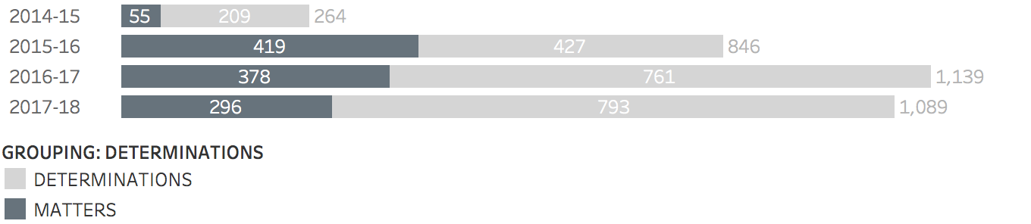

Base: All records where gender not stated (3,338).

Figure B1.1 shows there were 3,338 records where the gender of the client was not stated, of which 1,148 were matters (which represents 14.8% of all matters). The high number of records with no gender stated may be due to an increasing preference not to provide details of gender.

The completeness of data related to gender has reduced over time. In 2013/14, there were no records that had the gender field classified as unknown. However, this incompleteness affects determinations more than matters.

Figure B1.2 Records where ethnicity not stated

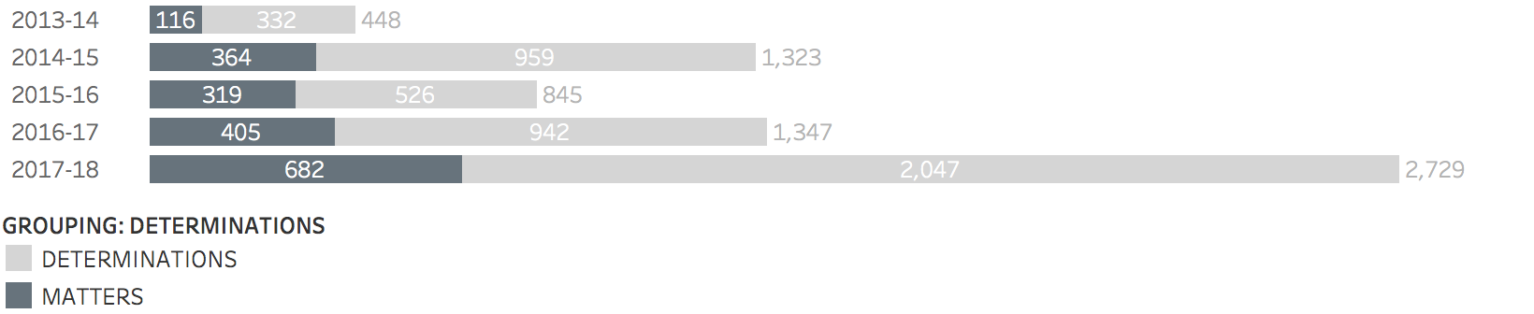

Base: All records where ethnicity not stated (6,692).

Figure B1.2 shows there were 6,692 records for which the ethnicity of the client was not stated, of which 1,186 were matters (which represents 15.3% of all matters).

The completeness of data related to ethnicity has also reduced over time. The highest number of unknown ethnicity records was in 2017/18 (2,729). This represents 57.3% of all records (see Figure 12.1).

Figure B1.3 Records where disability not stated

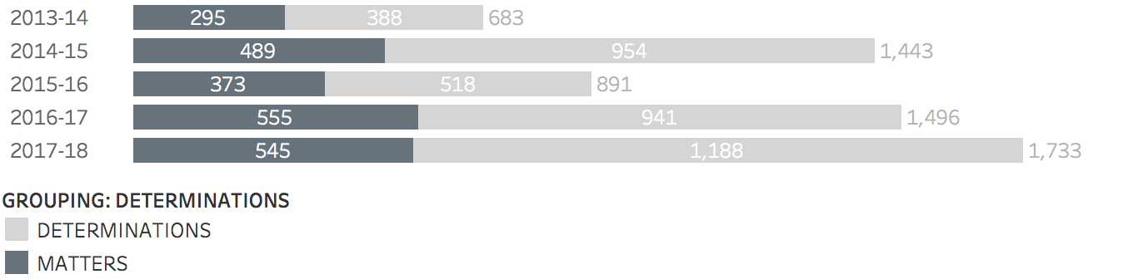

Base: All records where disability not stated (6,246).

Figure B1.3 shows there were 6,246 records where the disability of the client was not stated, of which 2,257 were matters (which represents 29.1% of all matters).

The data completeness of disability has fluctuated over time. The highest number of unknown disability records was in 2017/18 (1,733). This represents 36.4% of all records (Figure 12.1).

Contacts

This publication and related equality and human rights resources are available from [our website](http://www.equalityhumanrights.com).

Questions and comments regarding this publication may be addressed to: [correspondence@equalityhumanrights.com](mailto:correspondence@equalityhumanrights.com). We welcome your feedback.

For information on accessing one of our publications in an alternative format, please contact: [correspondence@equalityhumanrights.com](mailto:correspondence@equalityhumanrights.com).

Keep up to date with our latest news, events and publications by [signing up to our e-newsletter](https://www.equalityhumanrights.com/en/newsletter-sign).

**EASS**

For advice, information or guidance on equality, discrimination or human rights issues, please contact the [Equality Advisory and Support Service](http://www.equalityadvisoryservice.com), a free and independent service.

Telephone 0808 800 0082

Textphone 0808 800 0084

Hours 09:00 to 19:00 (Monday to Friday)

10:00 to 14:00 (Saturday)

Post FREEPOST EASS HELPLINE FPN6521

© 2019 Equality and Human Rights Commission

Published June 2019

ISBN: 978-1-84206-801-4

1. See A. Patel (2014), [‘Civil Legal Advice mandatory gateway: A secondary analysis of management information’](https://assets.publishing.service.gov.uk/government/uploads/system/uploads/attachment_data/file/384311/cla-mandatory-gateway-secondary-analysis-management-information.pdf) (Ministry of Justice).
2. See Ministry of Justice (2019), [‘Post-Implementation Review of Part 1 of the Legal Aid, Sentencing and Punishment of Offenders Act 2012 (LASPO)’](https://assets.publishing.service.gov.uk/government/uploads/system/uploads/attachment_data/file/777038/post-implementation-review-of-part-1-of-laspo.pdf) (Ministry of Justice).
3. See [‘Legal Aid Scheme: Telephone Services: Written question – 111873’](https://www.parliament.uk/business/publications/written-questions-answers-statements/written-question/Commons/2017-11-07/111873/) (November 2017).
4. Ibid., this table is reproduced from the same parliamentary question.