Equality and Human Rights Commission

Civil Legal Advice: analysis of Public Funding Certificate data

June 2019

Pawel Jancz

(Numbertelling)

Contents

1. Background 3

2. PFCs granted: Discrimination category 6

3. PFCs granted: Other Category (Discrimination) 10

4. Refusals 14

5. Comparison between PFC Discrimination and PFC Other Category (Discrimination) Grants 17

6. Conclusions 18

Appendix A: Grouping criteria 19

Contacts 20

1. Background

The Equality and Human Rights Commission (‘the Commission’) commissioned Numbertelling in November 2018 to assist with its inquiry into legal aid for the victims of discrimination. This report focuses on granted and refused applications for Public Funding Certificates (PFCs). A PFC is normally applied for as a second stage of funding when funding is required to take a case to court.

At the initial funding stage (known as ‘Legal Help’), help and advice can be obtained from a solicitor. This level of funding does not cover the lawyer representing their client at court. The funding does cover assistance in the background; for example, by helping a client to draft the claim and a witness statement. To secure legal representation at court, the solicitor needs to apply for a PFC. It should be noted that a PFC cannot cover legal representation for Employment Tribunal cases or County Court cases that are likely to be allocated to the ‘small claims track’.

Legal aid contractual arrangements divide the types of work that can be funded into different categories of law. Normally only those providers of legal aid services who hold a contract in a category of law can apply for a PFC in that category of work. For the Discrimination category of law, the Civil Legal Advice (CLA) specialist providers contracted by the Legal Aid Agency (LAA) to provide advice in discrimination cases can apply for a PFC in discrimination work.

In some cases, another legal aid solicitor can also take on a discrimination case. For example, if a case relates to another category of law, such as housing, in which a solicitor has a contract to provide legal aid, they can advise on a discrimination case in the housing context if there has been a contravention of the Equality Act 2010 and can apply for a PFC to take the case to court in appropriate circumstances.

In this report, separate analyses have been conducted of PFCs in the Discrimination category of law and of PFCs in other categories of law where an element of discrimination exists. We refer to these two groups in the report as ‘PFC Discrimination’ and ‘PFC Other Category (Discrimination)’. Section 2 of the report focuses on PFC Discrimination cases and Section 3 on PFC Other Category (Discrimination) cases. The PFC Other Category (Discrimination) group comprises cases linked in the LAA’s data to a discrimination or equality-related proceedings code. The group does not capture cases that relate to equality and discrimination law but which are linked to other proceedings codes and for which the lead proceeding code is **not** discrimination. For example, a Public Law case may raise Equality Act issues without them being specified as the leading code on the PFC.

Numbertelling’s work involved analysing a dataset provided by the LAA that contains details of granted and refused applications for PFCs, covering PFC Discrimination and PFC Other Category (Discrimination). The details include information such as age, disability, category of law, matter type, and outcome information (stage end, method of resolution, outcome and whether alternative dispute resolution was used). The dataset covers England and Wales (but not Scotland) and contains all relevant records from 2013/14 to 2017/18. It also contains 2012/13 and 2018/19 records, but these have been excluded from the analysis as they only contained partial annual information.

The dataset used for the analysis consists of data extracts from two different management systems: CIS (Corporate Information System) and CCMS (Client and Cost Management System). These two systems collect data in a similar fashion and with similar coding, which allowed the two datasets to be blended without major issues. The LAA initially used the CIS system only, before gradually moving to the CCMS system; by 2016/17, the LAA largely used the CCMS system. Differences in the information collected by the two systems are discussed in Appendix A. Where possible, we also compared our analysis of the LAA dataset with relevant published data from the Ministry of Justice as part of its legal aid statistics. The Ministry of Justice data consists of three tables, covering ‘Civil representation, applications received in period and grant status’; ‘Civil representation, certificates granted in period’; and ‘Civil representation, certificates completed’.[1]

Table 1.1 shows the total number of PFC Discrimination and PFC Other Category (Discrimination) grants between 2013/14 and 2017/18.

Table 1.1 Total number of PFC grants, 2013/14 to 2017/18

| **Year** | **PFC discrimination** | **PFC Other category (Discrimination) grants** | **Total grants** |
| --- | --- | --- | --- |

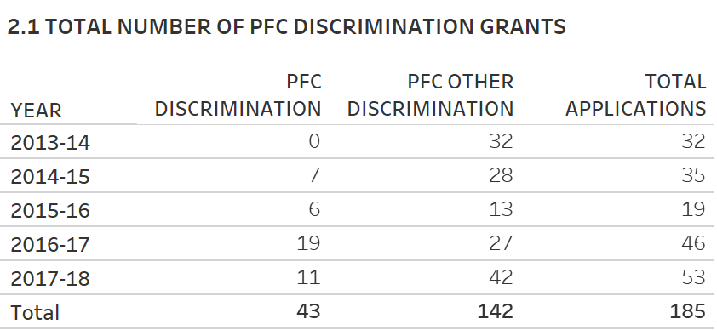

2. PFCs granted: Discrimination category

In this section, we examine grants for PFCs in the Discrimination category of law.

As Table 1.1 shows, the LAA dataset showed 43 PFC Discrimination grants in total between 2013/14 and 2017/18. No grants were made in 2013/14 and the highest number of grants were made in 2016/17.

Table 2.1 presents data on PFC applications and grants from legal aid statistics published by the Ministry of Justice for selected categories. We found a small difference between the Ministry of Justice’s and LAA’s datasets in the total number of applications granted in the Discrimination category over the period as a whole. There were larger differences when year-on-year data was compared (this data is not shown in Table 2.2). Due to the different sources, the total number of Discrimination grants shown in Table 2.1 is therefore 45 rather than 43 as it is in Table 1.1. Our understanding is that official Ministry of Justice statistics are generated using extract and reporting requirements different from those used to provide the LAA dataset on which this report focuses.

Table 2.1 PFC applications and grants for selected categories, 2013/14 to 2017/18

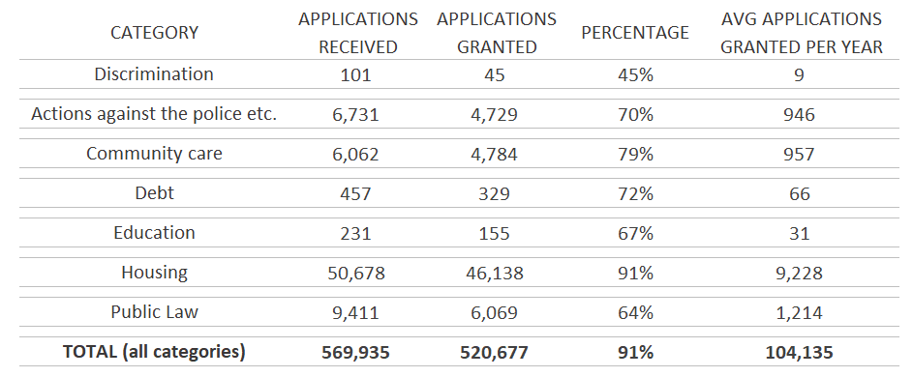

Note: The total (all categories) figures include family, immigration and mental health cases, as well as other non-family categories, such as clinical negligence. ‘Family’ represents by far the largest category of all applications every year (85.4% in 2017/18, for example).

Source: Ministry of Justice[, ‘Legal Aid Statistics England and Wales Tables July to September 2018’](https://www.gov.uk/government/statistics/legal-aid-statistics-july-to-september-2018), Tables 6.1 and 6.2.

Table 2.1 shows that, although overall a high proportion of total applications result in grants (91%), within the Discrimination category only 45% of applications between 2013/14 and 2017/18 resulted in grants. Of all the categories listed in the table, the proportion of applications resulting in grants was the lowest for the Discrimination category by a considerable margin.

Figure 2.2 Total number of PFC Discrimination grants by category of law



Note: Null refers to the fact that the specific fields were not populated in the dataset.

Base: All PFC Discrimination grants (43).

Figure 2.2 shows that of the 43 PFC Discrimination grants, 36 were in the Discrimination category of law; the other 7 cases were not included in the dataset.

Figure 2.3 Total number of PFC Discrimination grants by disability

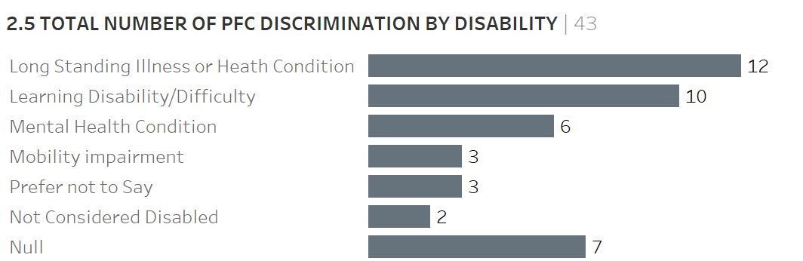

Note: This data relates to self-declared disability or illness. The CIS dataset did not contain this information; therefore the 7 Null cases are related to this dataset.

Base: All PFC Discrimination grants (43).

Figure 2.3 shows that, in the great majority of cases where data was available and provided (31 out of 36 cases), the client was disabled.

Figure 2.4 Total number of PFC Discrimination grants by full representation, 2014/15 to 2017/18

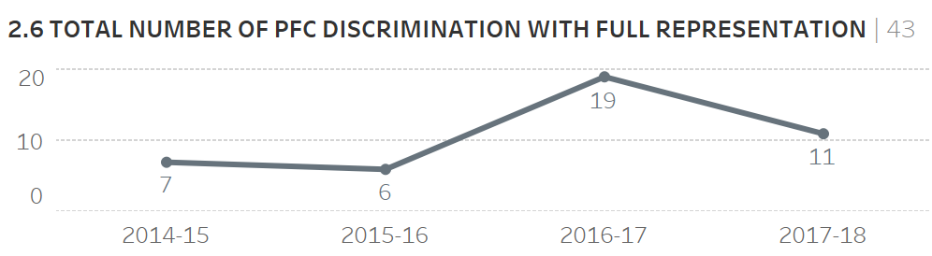

Base: All PFC Discrimination grants (43).

PFCs provide for either ‘full representation’ or ‘investigative representation’; investigative representation is limited to investigation into the strength of the claim. In practice, there may not be much difference between the amount of support provided to the client under full or investigative representation. Figure 2.4 shows that all Discrimination cases where grants were awarded involved full representation rather than investigative representation.

Figure 2.5 Total number of PFC Discrimination grants by stage end

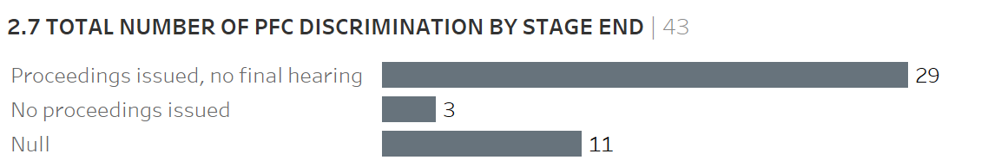

Base: All PFC Discrimination grants (43).

Figure 2.5 shows that, in 67% (29 cases) of granted applications, the case ended after proceedings were issued but before a final hearing took place.

Proceedings were not issued in only 7% (3 cases) of the granted applications. These cases were withdrawn on the recommendation of the solicitor or counsel, with one case having a negative, and the other two having an unknown, associated resolution code.

Of the granted applications in the dataset, 25% (11) were not populated with any outcome codes (Null cases). This may be explained by some cases still being open.

Figure 2.6 Total number of PFC discrimination grants by method of resolution

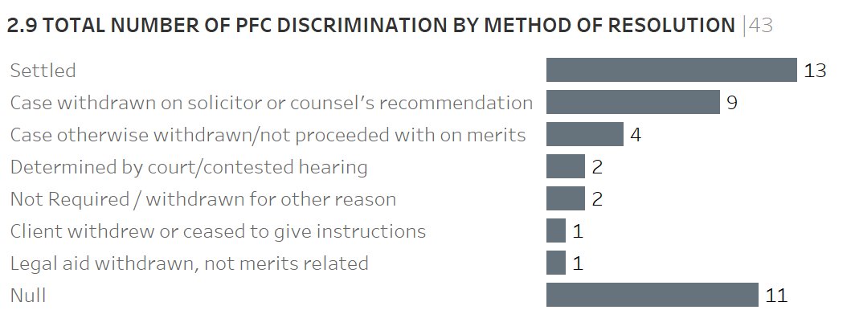

Note: Null records relate to cases where no outcome code for method of resolution was available in the dataset.

Base: All PFC Discrimination grants (43).

Figure 2.6 shows that 30% (13) of the cases were settled. Most of the remaining cases (17) were withdrawn, either on the solicitor’s recommendation, on the merits, or for some other reason. Two cases were determined by the court.

Figure 2.7 Total number of PFC Discrimination grants by result

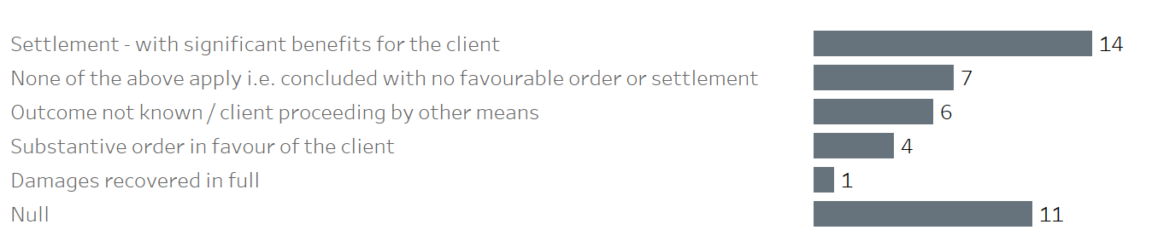

Note: Null records relate to cases where no outcome code was available in the dataset.

Base: All PFC Discrimination grants (43).

Figure 2.7 shows that nearly half of the cases where the outcome was known (14 out of 32) resulted in settlement with the client receiving a significant benefit. The LAA describes ‘significant benefit’ as one that a reasonable privately paying client would regard as sufficiently worthwhile to justify having taken or defended proceedings. A further five cases resulted in a favourable order or recovery of damages. Seven cases resulted in no favourable order or settlement being made to the client. In six cases the outcome was unknown and no additional information was available.

3. PFCs granted: Other Category (Discrimination)

In this section, we examine grants for PFCs relating to discrimination but classified under other categories of law.

As Table 1.1 above shows, the LAA dataset showed 142 PFC Other Category (Discrimination) grants in total between 2013/14 and 2017/18 and the number of applications granted was fairly similar in most years, except for 2015/16. In comparison with PFC Discrimination grants shown in Table 1.1, there were a higher number of PFC Other Category (Discrimination) grants in each year.

Figure 3.1 Total number of PFC Other Category (Discrimination) grants by proceeding code

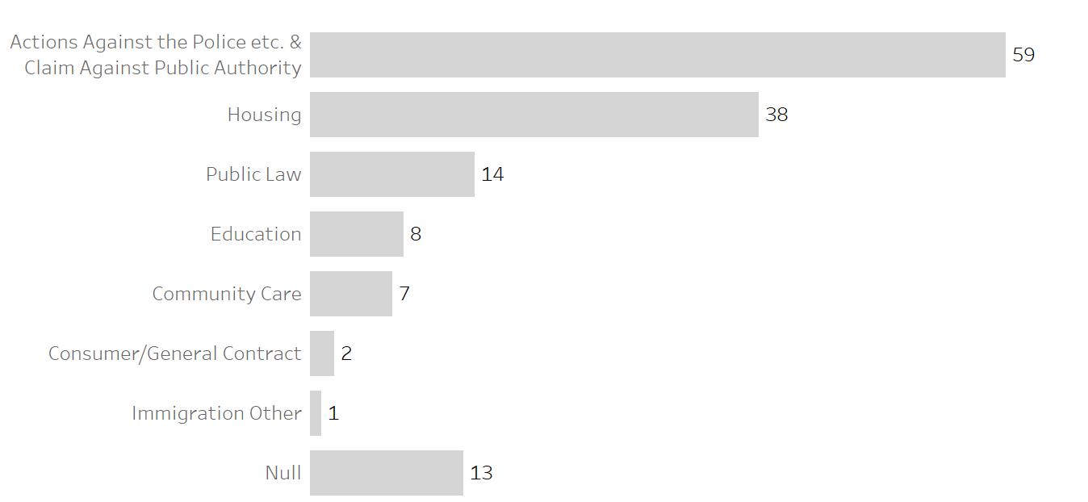

Note: The description of the same codes differed in the two datasets. The CIS code was ‘Actions Against the Police etc.’ and the CCMS code was ‘Claims Against Public Authority’. We have grouped these as we feel that the codes are essentially the same.

Base: All PFC Other Category (Discrimination) grants (142).

Figure 3.1 shows that the largest number of PFC Other Category (Discrimination) grants concerned actions against the police or claims against a public authority, followed by those in the housing category.

Figure 3.2 Total number of PFC Other Category (Discrimination) grants by disability

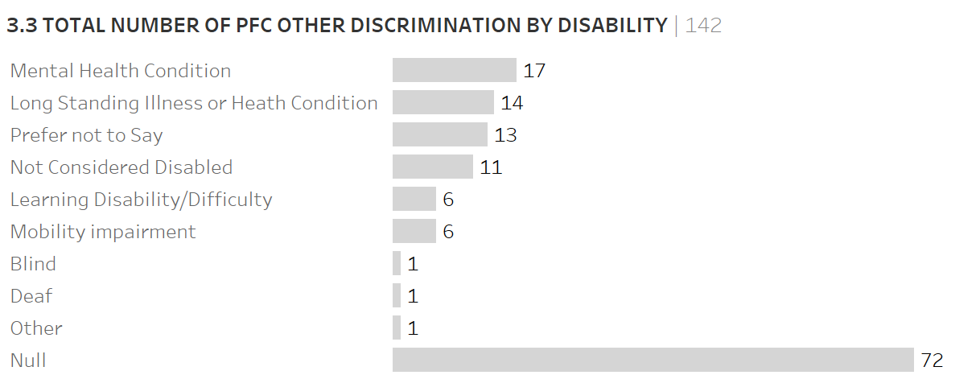

Note: The CIS dataset did not contain a Disability variable; therefore the 72 Null cases come from the CIS dataset.

Base: All PFC Other Category (Discrimination) grants (142).

Figure 3.2 shows that, in the majority of cases where a grant was awarded (59 out of 70), the client was considered disabled.

Figure 3.3 Total number of PFC Other Category (Discrimination) grants with full representation, 2013/14 to 2017/18

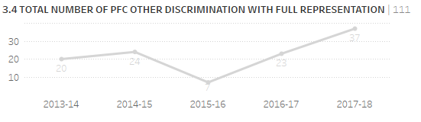

Base: All PFC Other Category (Discrimination) grants with full representation (111).

Figure 3.3 shows a stable number of applications provided with full representation, except in 2015/16. The increase of activity in 2017/18 correlates to the overall increase of applications in that year.

Figure 3.4 Total number of PFC Other Category (Discrimination) grants with investigative representation, 2013/14 to 2017/18

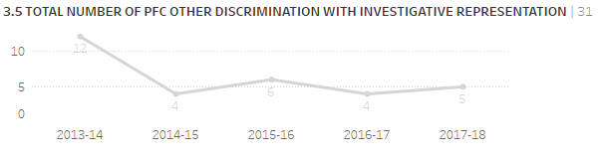

Base: All PFC Other Category (Discrimination) grants with investigative representation (31).

Figure 3.4 shows that there was a decrease in investigative representation after 2013/14.. In any case, and as noted above, the distinction between full representation and investigative representation is not substantial in practice.

Figure 3.5 Total number of PFC Other Category (Discrimination) grants by stage end

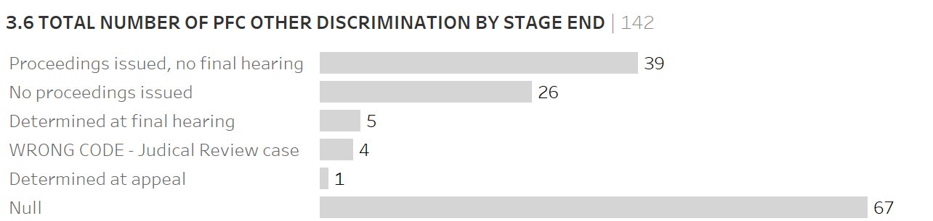

Note: 47% of the dataset (67) were not populated with any outcome codes (Null cases). This might be related to cases still being open, but it is not possible to confirm this based on provided data. ‘WRONG CODE’ refers to the fact that it is unclear from the dataset documentation for the code (E) whether proceedings were issued or not.

Base: All PFC Other Category (Discrimination) grants (142).

Figure 3.5 shows that in 27% (39) of granted applications, proceedings were issued but did not proceed to final hearing.

Figure 3.6 Total number of PFC Other Category (Discrimination) grants by method of resolution

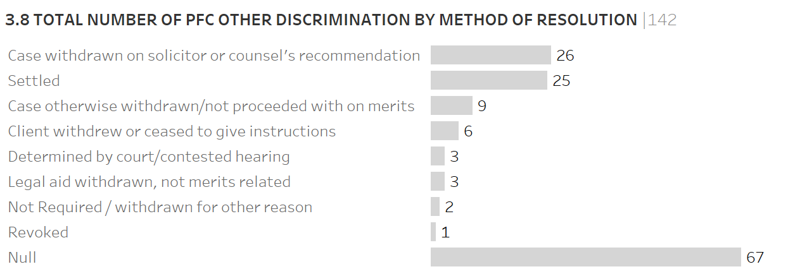

Note: Null records 47% (67) relate to cases where no outcome code is available in the dataset.

Base: All PFC Other Category (Discrimination) grants (142).

Figure 3.6 shows that 18% (26) of the cases were withdrawn on the solicitor or counsel’s recommendation and, of those, 1 had a positive, 22 had a negative, and 3 had an unknown result. Of the cases, 18% (25) were settled and, of those, 22 had a positive result and 3 had a negative result.

Figure 3.7 Total number of PFC Other Category (Discrimination) grants by result

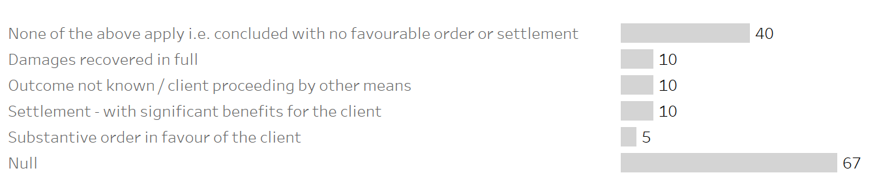

Note: Null records 47% (67) relate to cases where no outcome code has been available in the dataset.

Base: All PFC Other Category (Discrimination) grants (142).

Figure 3.7 shows that, of the 75 cases for which an outcome code was available, more than half (40) had no specific code allocated to the case result and did not result in a positive outcome; 10 cases had an unknown result code with no additional information available; and the remaining 25 had a positive outcome. Of these 25 with a positive outcome, 10 involved the client receiving a settlement with significant benefits in their favour from the settlement.

4. Refusals

The LAA dataset includes information on 25 refused PFC applications, covering both PFC Discrimination and PFC Other Category (Discrimination) cases. These were recorded in both the CIS and CCMS management systems. Since the number of refusals is small, only tentative conclusions can be drawn from the data.

Table 4.1 Total number of refused applications, 2013/14 to 2017/18

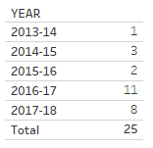

Base: All refused applications (25).

Table 4.1 shows that the number of refused applications in both 2016/17 and 2017/18 represented an increase when compared with earlier years. This pattern is in line with the overall increase in successful applications for those years.

Figure 4.2 Total number of refused applications by type of provider

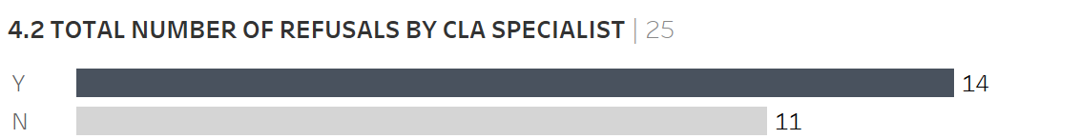

Notes: Y: applications made by CLA specialist discrimination providers

N: applications made by other legal aid providers

Base: All refused applications (25).

Figure 4.2 compares the number of applications which were made by a CLA specialist discrimination provider with those which were made by other legal aid providers. It shows that the majority (14 out of 25) were made by specialist providers.

Figure 4.3 Total number of refused applications by disability

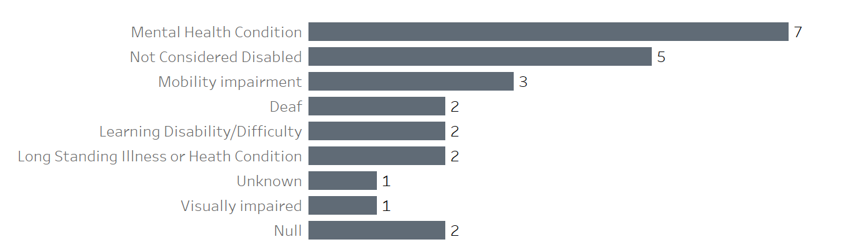

Base: All refused applications (25).

Figure 4.3 shows that most clients who were refused a PFC were disabled (17 out of 22 cases, excluding the null and unknown categories).

Figure 4.4 Total number of refused applications by category of law

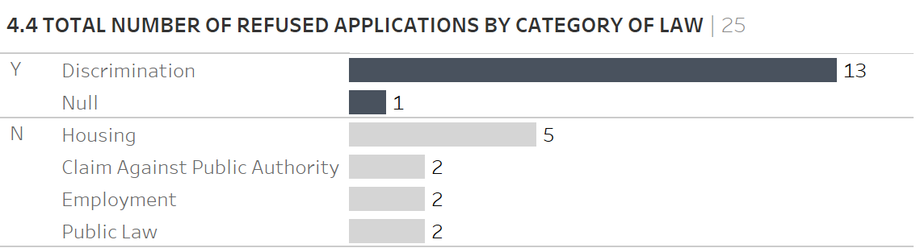

Notes: Y: applications made by CLA specialist discrimination providers

N: applications made by other legal aid providers

Base: All refused applications (25).

Figure 4.4 shows that refusals were fairly evenly divided between total Discrimination and Other Category (Discrimination) cases (13) and other cases (12).

Figure 4.5 summarises all the reasons that are given for each refused application. An application for a PFC can be refused for more than one reason, and up to three narrative reasons for refusing the applications were provided for each of the 25 cases (meaning that the total number of reasons given exceeds 25).

Figure 4.5 All reasons given for refused applications

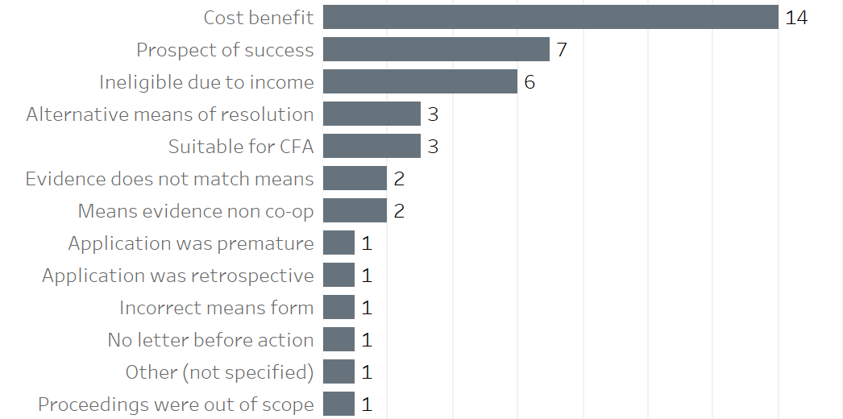

Notes: The categories above were devised by the Commission and therefore do not correspond with codes in the dataset.

Base: All reasons given for refusing an application (43).

Figure 4.5 shows that cost–benefit reasons account for almost a third (14 out of 43) of the reasons given.

5. Comparison between PFC Discrimination and PFC Other Category (Discrimination) Grants

As noted earlier in this report, there have been many more PFC grants awarded in other categories of law where there is discrimination, that is, within PFC Other Category (Discrimination), than in the Discrimination category of law itself. It is not possible to state from the available data whether a higher proportion of applications have been successful in the Discrimination or Other Category (Discrimination) categories.

It is clear, however, that in both PFC Discrimination and PFC Other Category (Discrimination) cases for which the data was provided the majority of clients awarded grants were disabled. In both PFC Discrimination and PFC Other Category (Discrimination) cases, the majority of applications were provided with full representation rather than investigative representation; in fact, for PFC Discrimination, all received full representation. Finally, where the outcome is known, it appears that there was more likely to be a settlement with significant benefits for the client in PFC Discrimination than in PFC Other Category (Discrimination) cases.

6. Conclusions

This report analyses granted and refused applications for Public Funding Certificates (PFCs). A PFC is normally applied for as a second stage of funding where funding is required to take a case to court. The key findings are outlined below.

* The number of PFC grants awarded between 2013/14 and 2017/18 was much higher for PFC Other Category (Discrimination) than for PFC Discrimination. In total, 142 grants were awarded in other categories of law where there is an element of discrimination, compared with only 43 grants in the Discrimination category of law.
* Ministry of Justice statistics show that only 45% of applications in the Discrimination category resulted in grants, which represents less than half the proportion of applications resulting in grants across all categories (91%).
* In most cases where a grant was awarded the client was considered disabled.
* In nearly half of PFC Discrimination cases where the outcome was known, the client received a significant benefit. But the proportion of clients receiving a significant benefit in PFC Other Category (Discrimination) cases was much lower; only 10 out of 75 grants resulted in a significant benefit.
* When an application was refused, the application had been made in the majority of cases by a Civil Legal Advice (CLA) discrimination specialist.

An analysis of all the reasons given for refusing a grant shows that cost–benefit reasons account for a nearly a third (14 out of 43) of the reasons given.

Appendix A: Grouping criteria

The following detail is the grouping specification that has been used for PFC Discrimination and PFC Other Category (Discrimination).

PFC Discrimination | DEFINITION

Applications have been classed as PFC Discrimination based on following criteria:

CIS records: [CLA Specialist?] = ‘Y’ AND [CAT OF LAW] = ‘OTH’

CCMS records: [CLA SPECIALIST] = ‘Y’ AND [CATEGORY] = ‘DISC

PFC Other Category (Discrimination) | DEFINITION

Applications that do not meet below specification have been classed as PFC Other Category (Discrimination):

CIS records: [CLA Specialist?] = ‘Y’ AND [CAT OF LAW] = ‘OTH’

CCMS records: [CLA SPECIALIST] = ‘Y’ AND [CATEGORY] = ‘DISC

Complete allocation results are shown below.

Appendix Table A.1 PFC grouping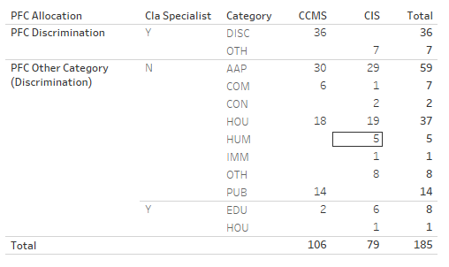

Contacts

This publication and related equality and human rights resources are available from [our website](http://www.equalityhumanrights.com).

Questions and comments regarding this publication may be addressed to: [correspondence@equalityhumanrights.com](mailto:correspondence@equalityhumanrights.com). We welcome your feedback.

For information on accessing one of our publications in an alternative format, please contact: [correspondence@equalityhumanrights.com](mailto:correspondence@equalityhumanrights.com).

Keep up to date with our latest news, events and publications by [signing up to our e-newsletter](https://www.equalityhumanrights.com/en/newsletter-sign).

**EASS**

For advice, information or guidance on equality, discrimination or human rights issues, please contact the [Equality Advisory and Support Service](http://www.equalityadvisoryservice.com), a free and independent service.

Telephone 0808 800 0082

Textphone 0808 800 0084

Hours 09:00 to 19:00 (Monday to Friday)

10:00 to 14:00 (Saturday)

Post FREEPOST EASS HELPLINE FPN6521

© 2019 Equality and Human Rights Commission

Published June 2019

ISBN: 978-1-84206-802-1

1. Ministry of Justice[, ‘Legal Aid Statistics England and Wales Tables July to September 2018’](https://www.gov.uk/government/statistics/legal-aid-statistics-july-to-september-2018), Tables 6.1, 6.2 and 6.3.